Synthesis of LTA-Type Zeolites (4A and 5A) from Local Kaolin and Investigation of Their Adsorption Properties
Shavkat P. Nurillaev, Oybek Yu. Aripdjanov, Boburbek M. Ismailov, Mirshoxid M. Mahammatov, Bekmurod Q. Muminov, Umida B. Mahkamova
Tashkent Institute of Chemical Technology — Tashkent, Uzbekistan
mahammatovmirshohidbek775@gmail.com
This study investigates the synthesis of LTA-type zeolites (4A and 5A) utilizing local kaolin from the Angren deposit as a primary precursor. Zeolite 4A was synthesized via the alkaline activation of kaolin followed by controlled hydrothermal crystallization, while zeolite 5A was subsequently produced through a liquid-phase ion-exchange process using calcium chloride. The structural and elemental characteristics of the synthesized samples were evaluated using scanning electron microscopy (SEM) and energy-dispersive X-ray spectroscopy (EDS). The analytical results confirmed the successful formation of the LTA-type framework and verified the efficient substitution of Na⁺ cations by Ca²⁺ during the ion-exchange process. Furthermore, the dynamic adsorption performance of the synthesized zeolites toward hydrogen sulfide (H₂S) was evaluated. The 5A zeolite sample demonstrated enhanced adsorption efficiency, indicating its high viability as an effective local adsorbent for the purification of acidic components from natural gas streams.
Keywords: kaolin, LTA zeolites, scanning electron microscopy (SEM), hydrogen sulfide adsorption, natural gas purification, adsorbents.
1. Introduction
In recent years, global and domestic demand for natural gas and its derivative products has experienced a steady increase. In the Republic of Uzbekistan, this trend necessitates substantial improvements in the efficiency of natural gas conditioning processes. The primary focus remains on dehydration and the rigorous removal of acidic and sulfur-containing contaminants, which otherwise induce equipment corrosion, degrade catalyst performance, and hinder compliance with strict regulatory standards (Aripdjanov et al., 2025a; Aripdjanov et al., 2025b).
Among the existing gas purification technologies, adsorption separation is widely recognized as highly efficient due to its exceptional selectivity, structural stability during thermal regeneration, and capacity for deep purification. Within this domain, synthetic zeolites—crystalline aluminosilicates characterized by well-defined porous frameworks and molecular sieving properties—play a critical role. According to the International Zeolite Association (IZA), while numerous natural frameworks exist, over 280 synthetic zeolite topologies have been cataloged, each exhibiting distinct structural metrics tailored for specific industrial separation tasks (Aripdjanov, 2024).
LTA-type zeolites, specifically frameworks 4A and 5A, are extensively utilized for concurrent natural gas dehydration and sour gas scavenging. The calcium-exchanged variant, zeolite 5A, features an effective pore aperture of approximately 0.5 nm, making it uniquely suited for the selective kinetic separation of water, carbon dioxide (CO₂), and hydrogen sulfide (H₂S). However, industrial gas-processing facilities in Uzbekistan currently rely almost exclusively on imported commercial adsorbents. This dependency increases operational expenditures and presents supply-chain vulnerabilities for the local gas-chemical sector.
To mitigate these challenges, leveraging the extensive, unexploited mineral reserves within the region offers a strategic alternative. The Republic of Uzbekistan possesses vast deposits of high-quality aluminosilicate minerals, notably kaolinitic clays. Utilizing local raw materials, such as those from the Angren deposit, as secondary silica and alumina precursors not only presents an economically viable pathway but also establishes a foundation for import-substituting material synthesis in petrochemical processing (Li et al., 2017; Miao et al., 2009).
Consequently, establishing a systematic synthesis route for LTA-type zeolites (4A and 5A) derived from regional kaolin precursors is of paramount importance. This study focuses on the synthesis of LTA-type zeolites (4A and 5A) using kaolin from the Angren deposit as a primary precursor. Furthermore, the structural evolution, phase purity, and morphological properties of the synthesized frameworks are comprehensively evaluated via scanning electron microscopy (SEM) and energy-dispersive X-ray spectroscopy (EDS) to verify their applicability in industrial natural gas purification.
2. Materials and Methods
2.1. Reagents and Materials
Enriched kaolin clays of AKC-30 and AKC-70 grades, sourced and beneficiated from the Angren deposit (Republic of Uzbekistan), were utilized as the primary aluminosilicate precursors. Analytical grade sodium hydroxide (NaOH) and calcium chloride (CaCl₂) were procured as chemical reagents, and all solutions were prepared using deionized water. A commercially manufactured zeolite 4A was employed as a benchmark reference sample for comparative structural and morphological analyses.
2.2. Synthesis of Zeolite 4A via Thermal Fusion
The synthesis of the zeolite 4A framework was performed using a thermal fusion route followed by controlled hydrothermal crystallization. Prior to chemical activation, a 10 g sample of AKC-30 kaolin was pre-dried in a laboratory oven at 110 °C for 10 h to remove residual moisture. The bone-dry kaolin was subsequently blended with solid sodium hydroxide (NaOH) in designated masses of 8.0 g, 10.0 g, and 12.0 g to establish distinct mass ratios.
The resulting homogeneous mixtures were calcined in a muffle furnace at 550 °C for 10 h to achieve complete structural collapse of the kaolinite into highly reactive amorphous metakaolin. After cooling to room temperature, the fused mass was dissolved in 100 mL of deionized water under vigorous stirring. To direct the nucleation pathway and accelerate the crystallization kinetics, 0.1 g (1.0 wt.%) of commercial zeolite 4A was introduced into the reaction gel as a crystalline seed material.
The synthesis gel was transferred into a 200 mL reaction vessel and allowed to homogenize at 30 °C for 3 h prior to hydrothermal crystallization. Subsequently, hydrothermal treatment was conducted at 90 °C for 5 h under constant mechanical agitation to facilitate framework growth. Upon completion, the synthesized crystalline phase was separated via vacuum filtration and washed repeatedly with deionized water until the filtrate reached a neutral pH. The obtained samples, designated based on their initial alkaline ratios, were subjected to final drying at 110 °C for 2 h.
The step-by-step structural transformation of the natural aluminosilicate precursor into the highly crystalline porous matrix was carried out according to the technological protocol outlined in Figure 1. The raw Angren kaolin underwent continuous thermal drying at 110 °C to eliminate physically bound moisture, followed by homogeneous blending with stoichiometric ratios of solid NaOH activator. The resulting mixture was subjected to high-temperature thermal fusion at 550 °C to break down the stable kaolinite sheets into reactive amorphous phases. Following subsequent aging and precise hydrothermal crystallization control at elevated temperatures, the synthesized zeolite framework was successfully recovered, washed, and prepared for structural characterization.

Raw Angren kaolin clay pre-treated matrix (AKC grade)
Thermal drying (110 °C, 10 h)
Alkaline activation (NaOH/Kaolin mass ratio: 0.8, 1.0, 1.2)
High-temperature alkaline fusion (550 °C, 1 h)
Zeolite seed addition (1 wt.% seed loading)
Room-temperature aging phase (30 °C, 3 h)
Hydrothermal crystallization treatment (90 °C – 95 °C, 3-5 h)
Synthesized crystalline zeolite adsorbent
Figure 1: Systematic flowchart illustrating the multi-stage alkaline fusion and hydrothermal crystallization pathway for synthesizing the porous zeolite adsorbents from natural Angren kaolin clay.
2.3. Preparation of Zeolite 5A via Ion Exchange
Zeolite 5A was prepared through a liquid-phase ion-exchange process utilizing the optimized zeolite 4A sample (designated as K4A-III) as the structural matrix. An aqueous solution of 1 M calcium chloride (CaCl₂) served as the calcium source.
A stoichiometric suspension of the synthesized K4A-III zeolite in the CaCl₂ solution was prepared and systematically agitated at 95 °C for 4 h using a magnetic stirrer maintained at a constant speed of 300 rpm. During this liquid-solid mass transfer process, the extra-framework Na⁺ cations within the LTA structure were successfully substituted by Ca²⁺ ions, thereby reducing the effective pore aperture to approximately 0.5 nm and yielding the zeolite 5A framework. The post-exchange crystalline product was isolated, washed with deionized water four times to eliminate residual chloride ions, and dried at 110 °C for 2 h. The finalized adsorbents were stored in a vacuum desiccator prior to characterization and adsorption experiments.
The dynamic adsorption performance of the synthesized LTA zeolites toward hydrogen sulfide (H₂S) was evaluated using a custom laboratory-scale gas purification setup, as illustrated in Figure 2. The model gas mixture was generated by blending pure methane and H₂S-containing methane source through calibrated mass flow meters into a gas mixing chamber. The composition of the binary gas mixture was constantly monitored at the inlet using an electrochemical gas analyzer. The gas stream was subsequently directed through a stainless-steel fixed-bed adsorber column packed with the synthesized zeolite granules. The residual concentration of the sour components at the reactor outlet was measured via an outlet gas analyzer to establish breakthrough curves. Exhaust gases were neutralized by scrubbing through a sodium hydroxide (NaOH) solution safety train followed by thermal flaring with a Bunsen burner.
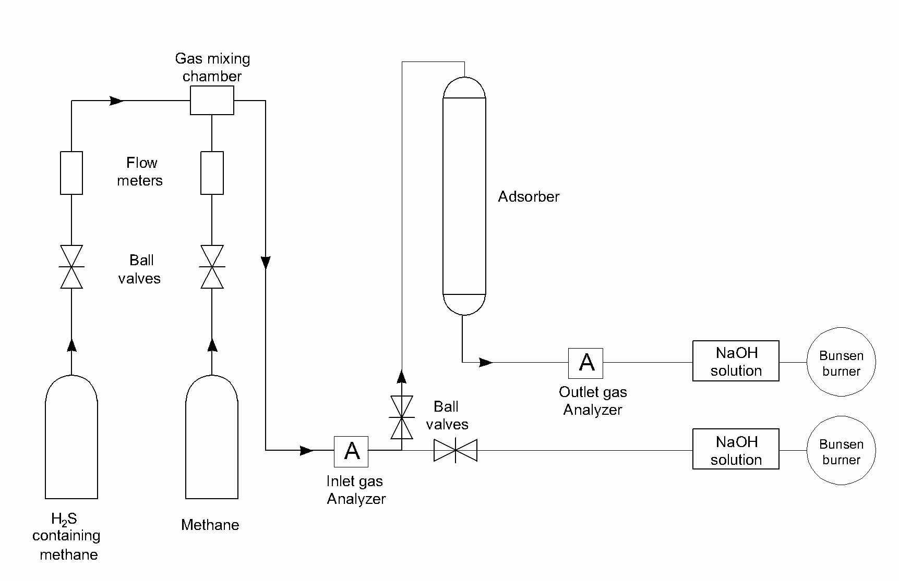
Figure 2: Laboratory setup for the purification of natural gas from moisture and acidic components
3. Results and Discussion
3.1. Sample Characterization and Morphological Analysis
The surface morphological features of the synthesized samples were investigated by scanning electron microscopy (SEM) using a Phenom ProX microscope (Phenom-World BV, Eindhoven, the Netherlands). Prior to SEM analysis, the samples were coated with a thin gold layer and mounted on an aluminum holder using double-sided carbon adhesive tape. To assess the effect of synthesis conditions on crystal morphology and size, Figure 3 presents the SEM micrographs of the initial kaolin and synthesized zeolites.
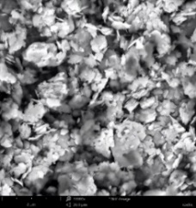 | 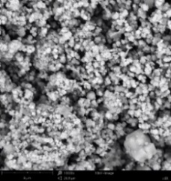 | 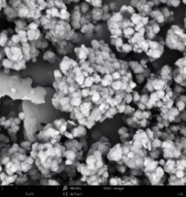 | 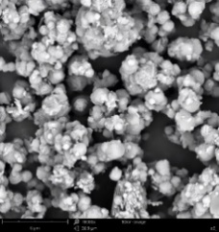 | 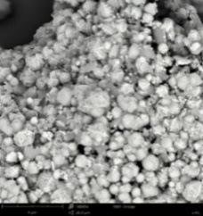
a) | b) | c) | d) | e)
Figure 3: SEM micrographs: (a) raw kaolin (AKC-30); (b) synthesized K4A-I; (c) synthesized K4A-II; (d) optimized K4A-III framework; (e) synthesized zeolite 5A-III obtained via ion exchange.
3.2. Results of Elemental Analysis
The elemental composition of the samples was determined by energy-dispersive X-ray spectroscopy (EDS) directly during SEM analysis using the built-in detector of the Phenom ProX microscope (Phenom-World BV, Eindhoven, the Netherlands).
The elemental composition of the initial kaolin and synthesized zeolites was investigated in spot analysis mode across several regions of each sample to assess the uniformity of element distribution and to confirm the formation of the zeolite structure. The corresponding EDS spectra and elemental microanalysis details are illustrated in Figure 4.
1a. Spot |  | 2a. spot
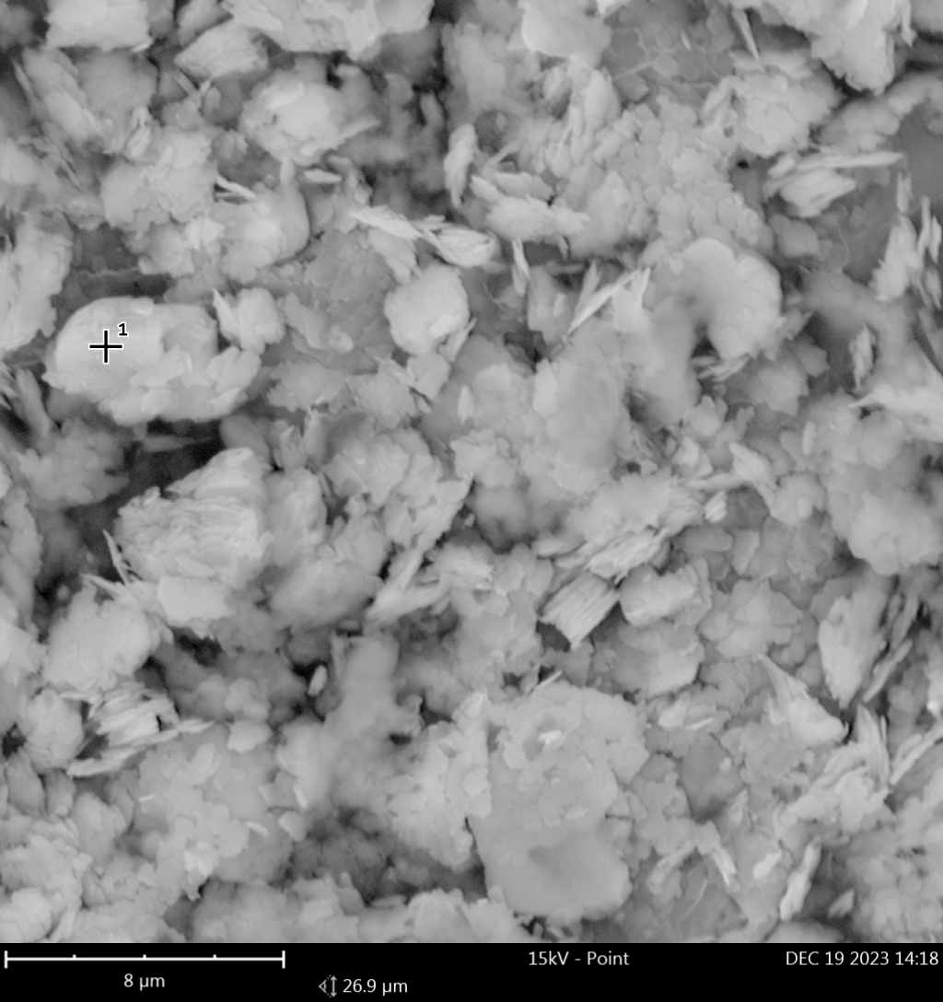 | 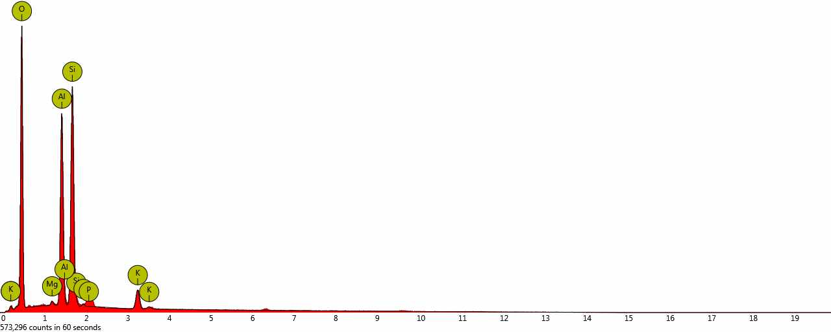 | 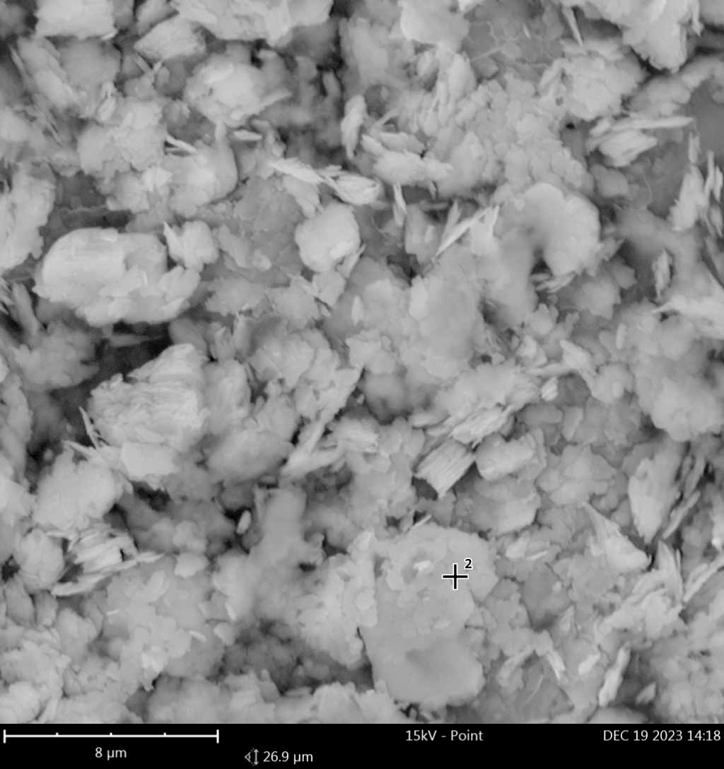 | 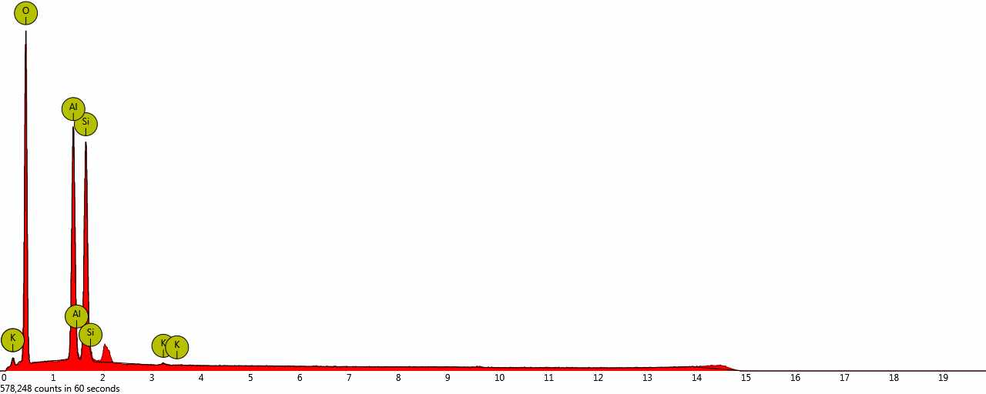
3a. spot |  | 4a. spot
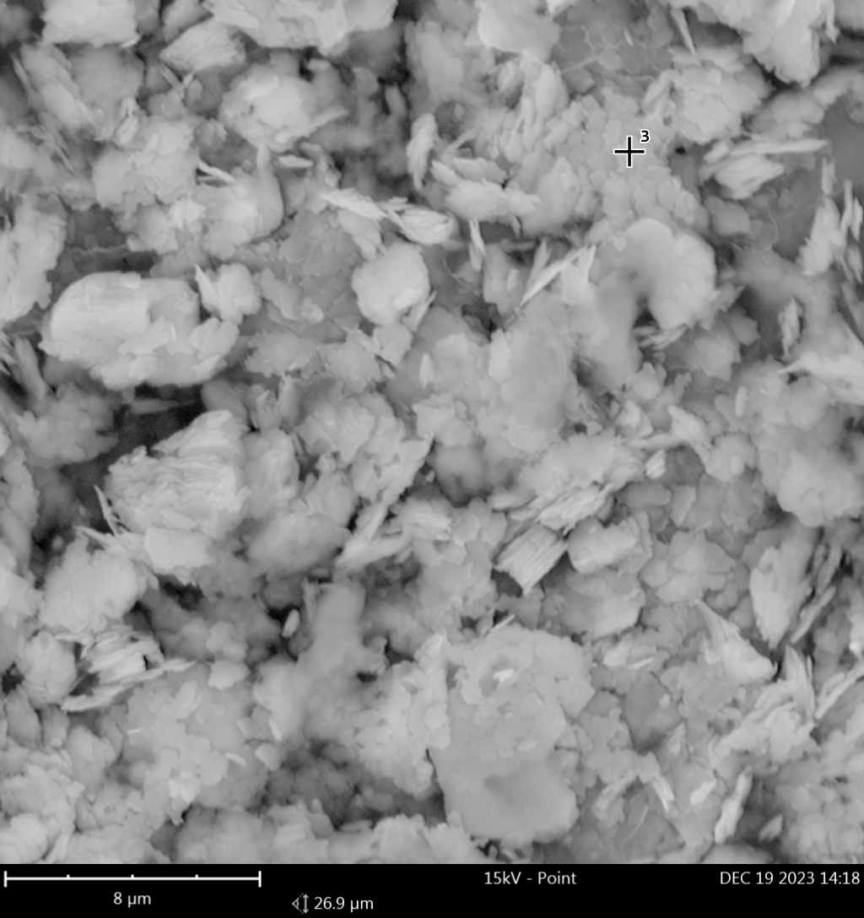 | 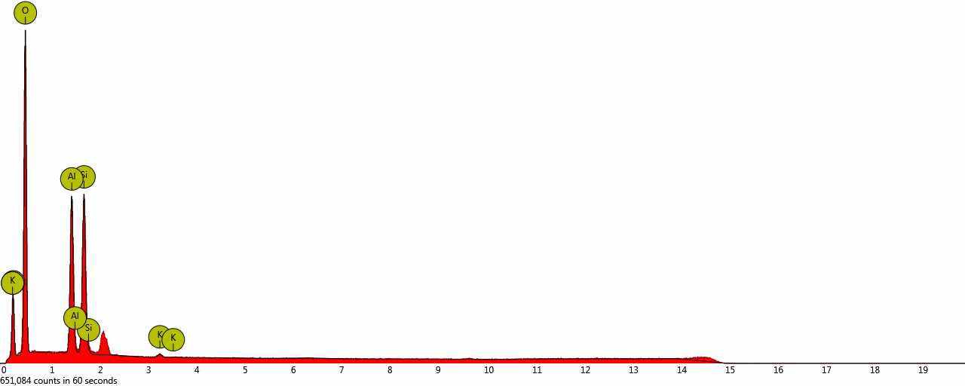 | 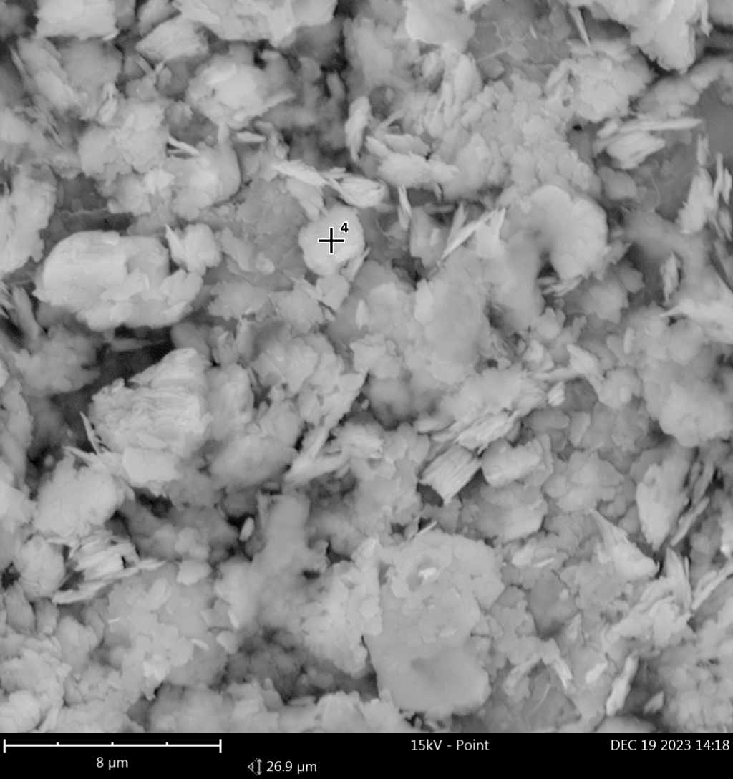 | 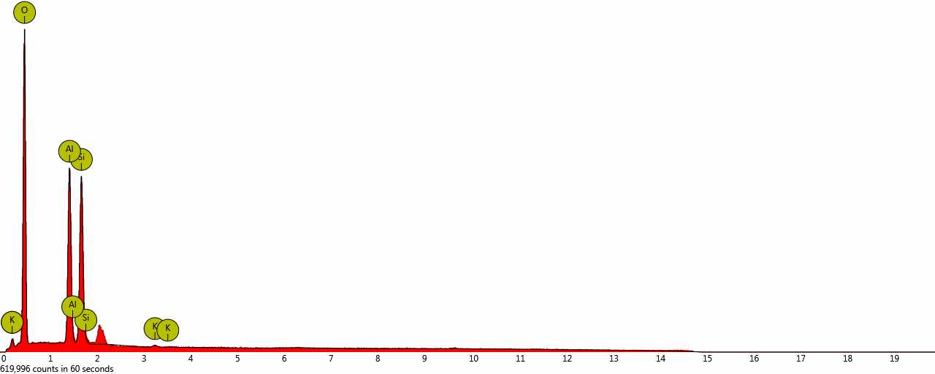
1b. spot |  | 2b. spot
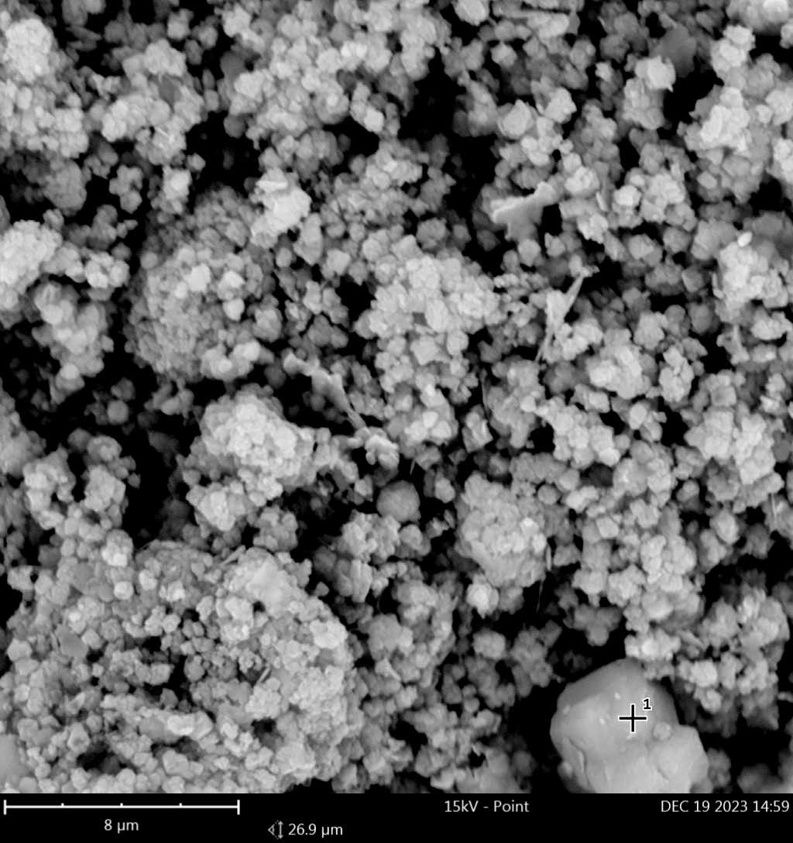 | 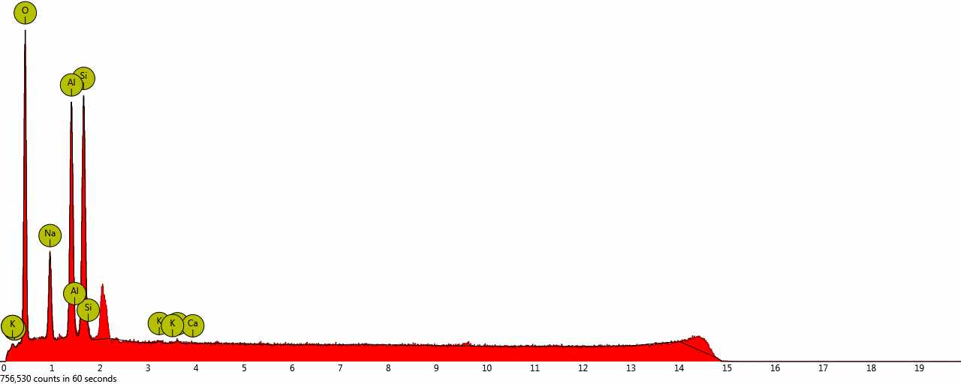 | 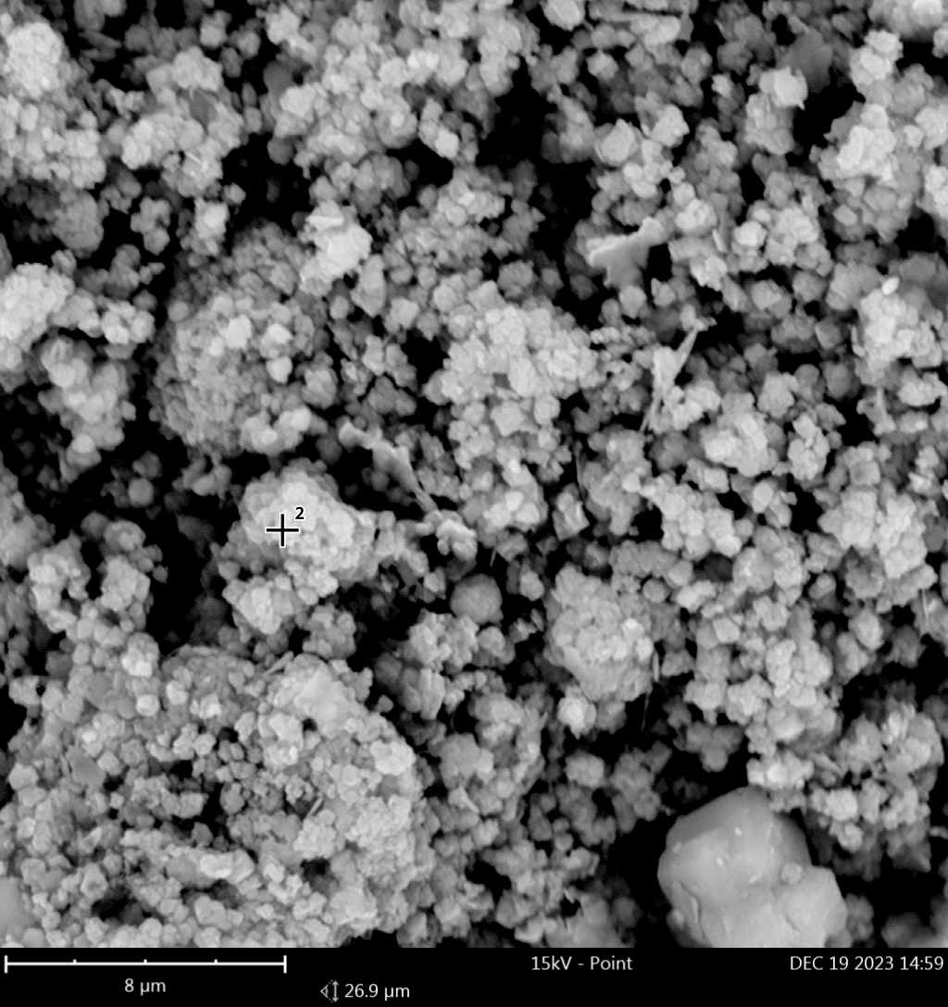 | 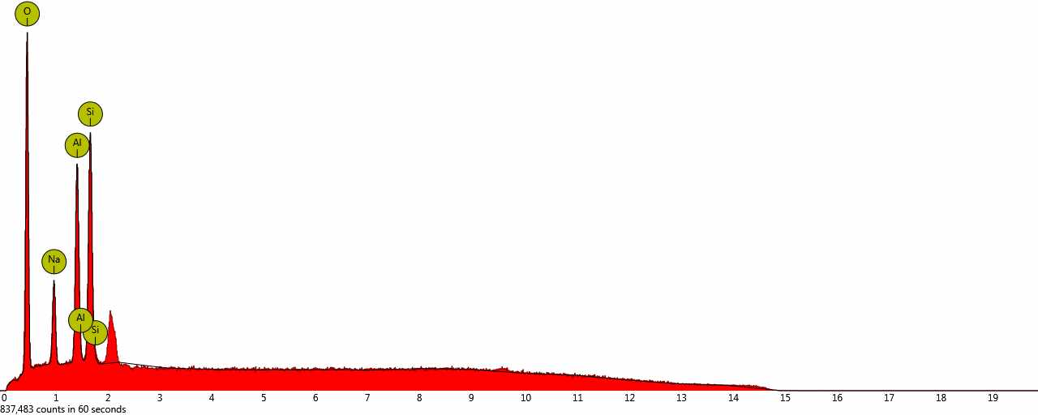
3b. spot |  | 4b. spot
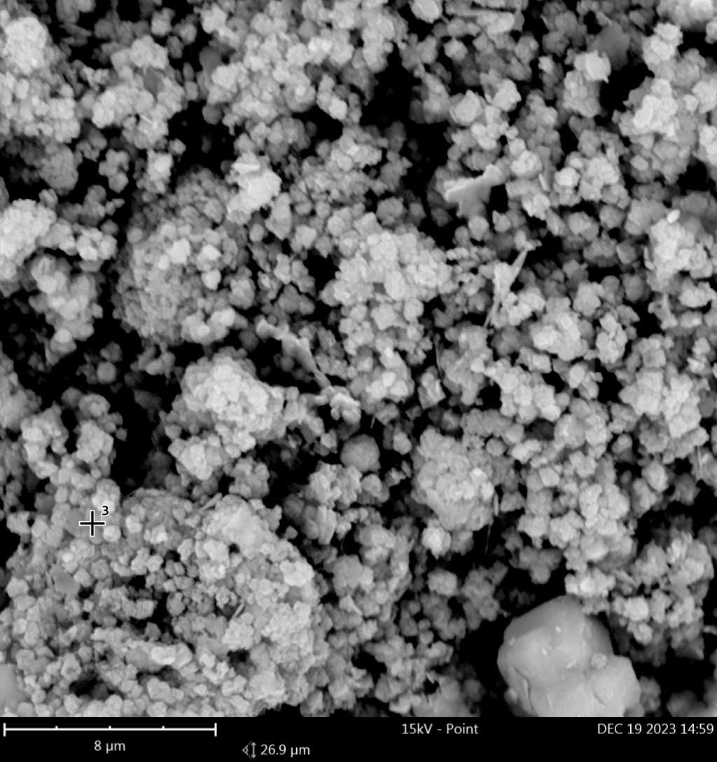 | 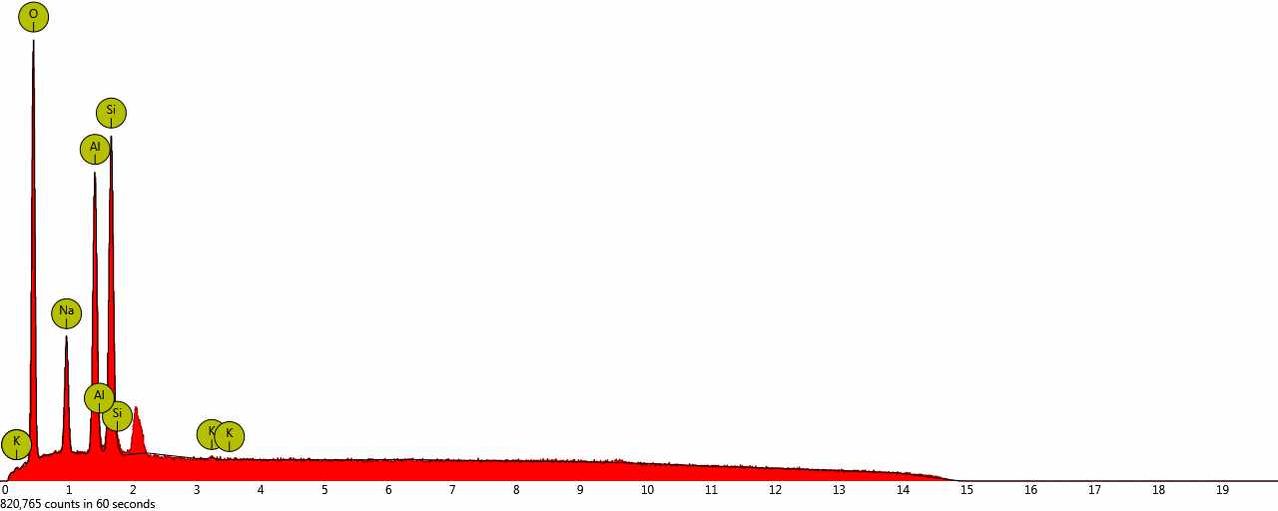 | 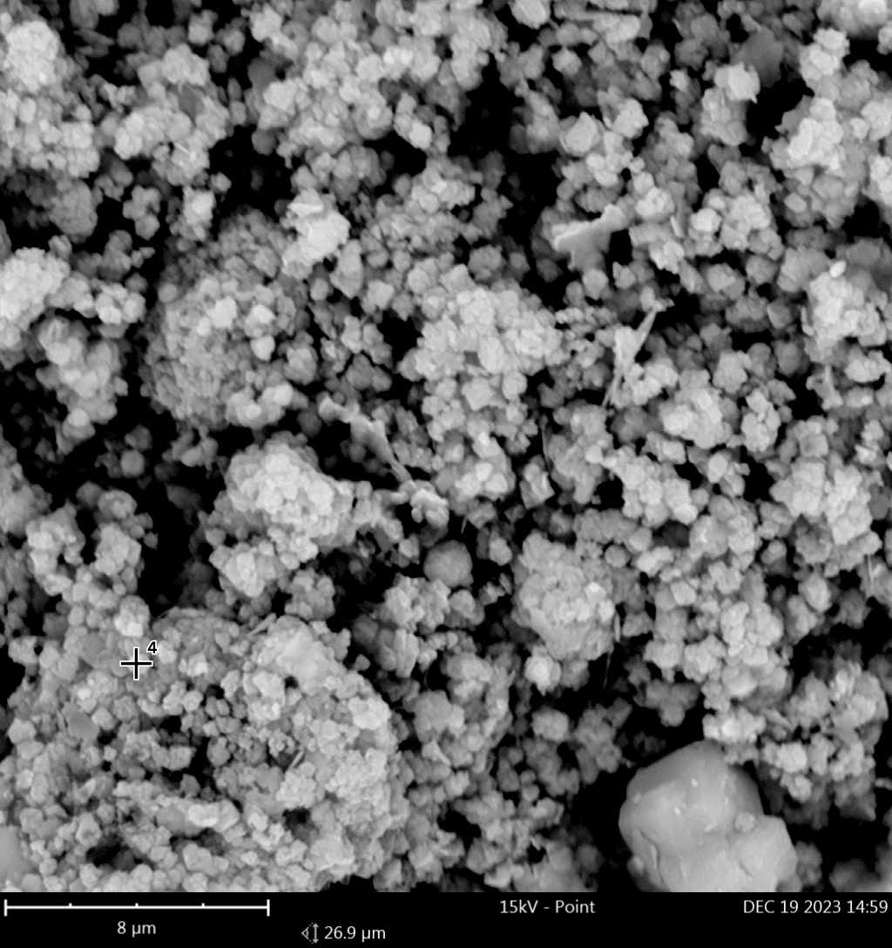 | 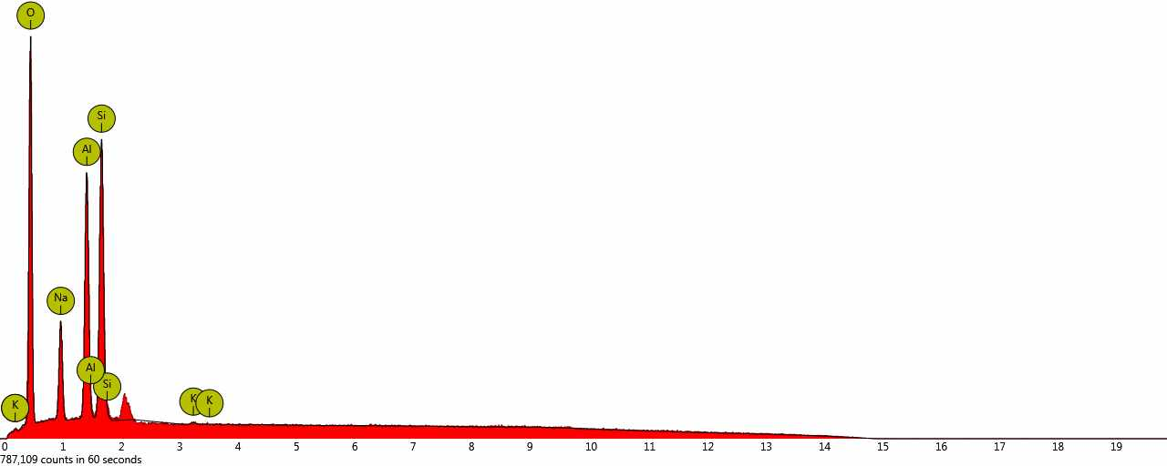
5b. spot |  | 6b. spot
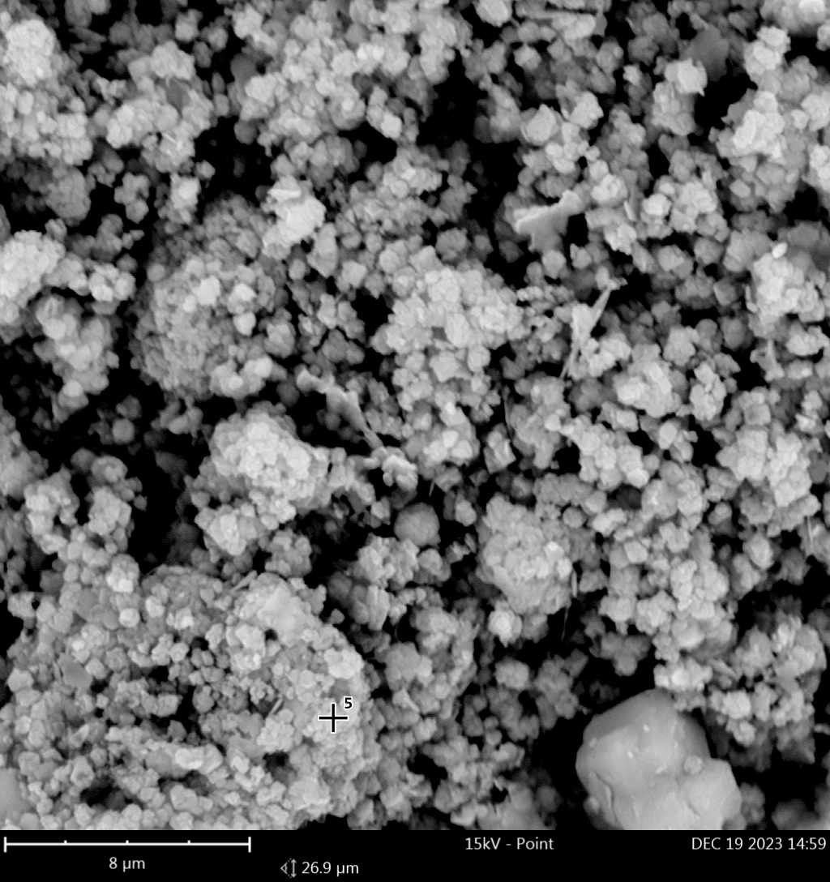 | 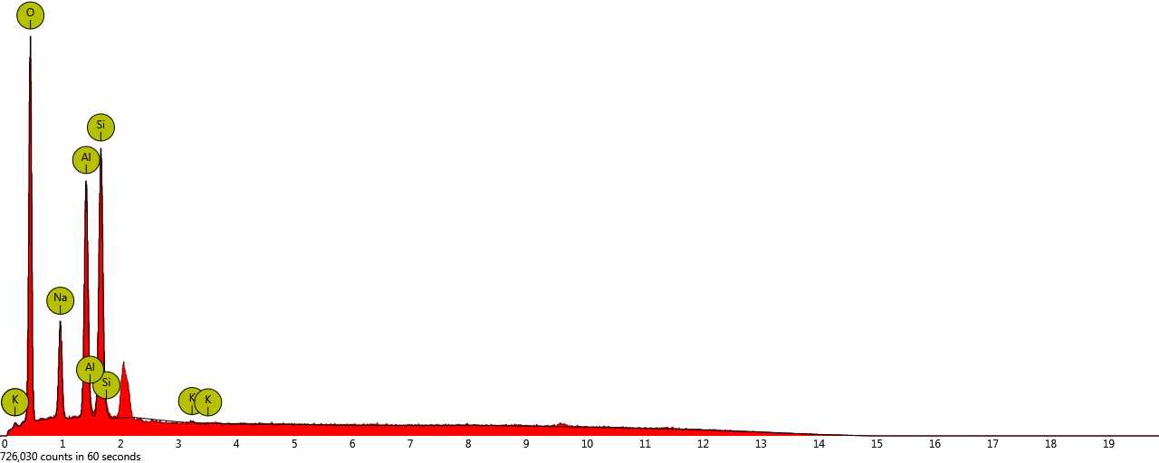 | 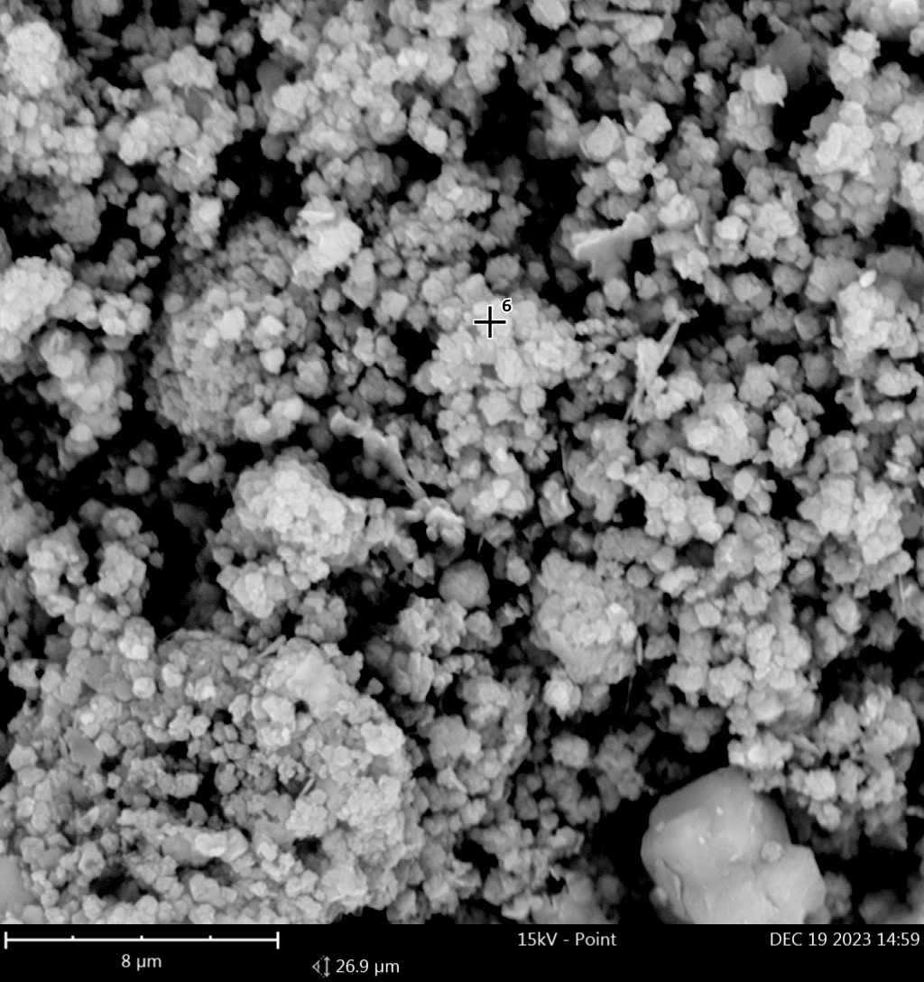 | 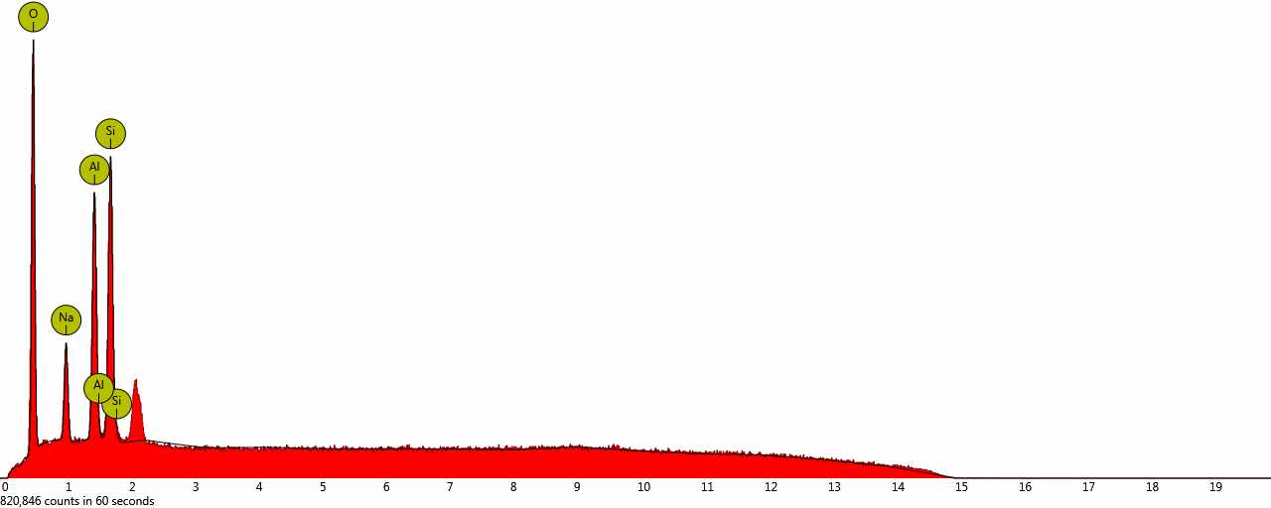
1c. spot |  | 2c. spot
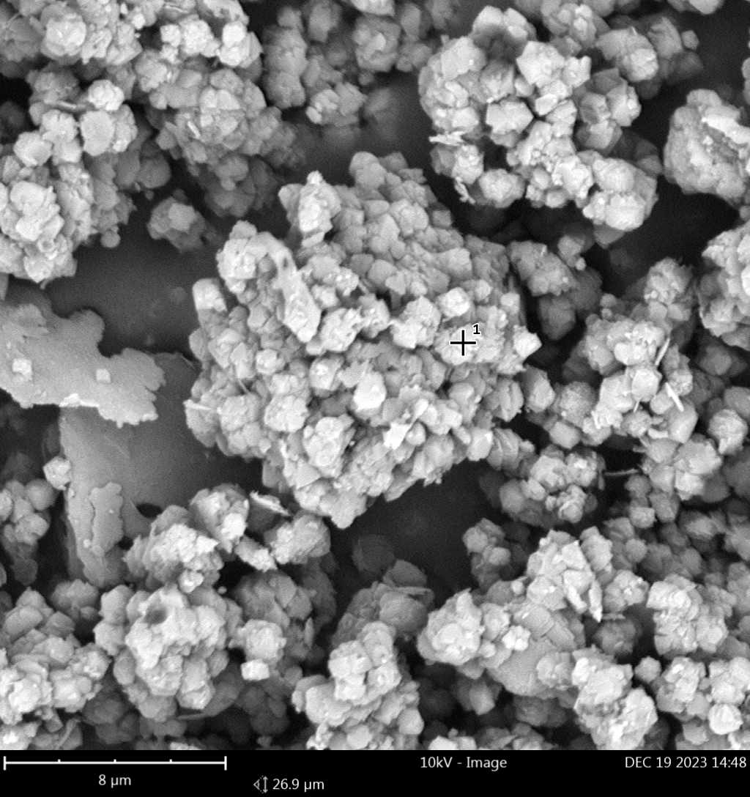 | 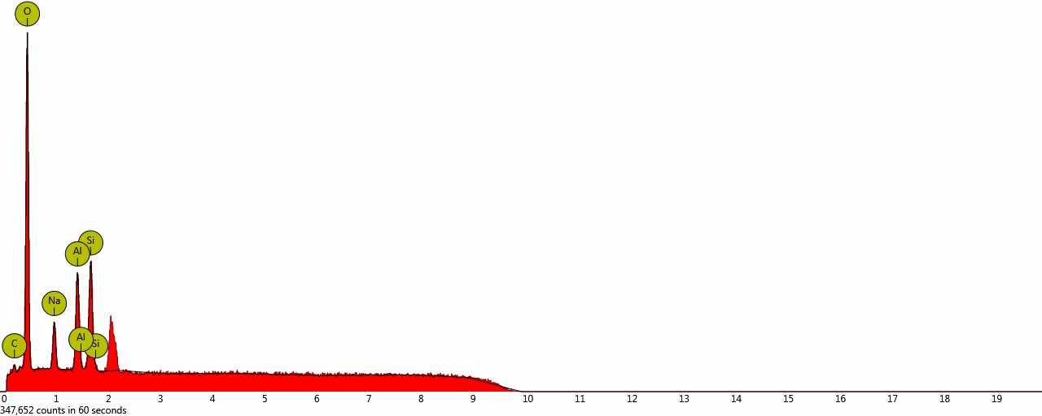 | 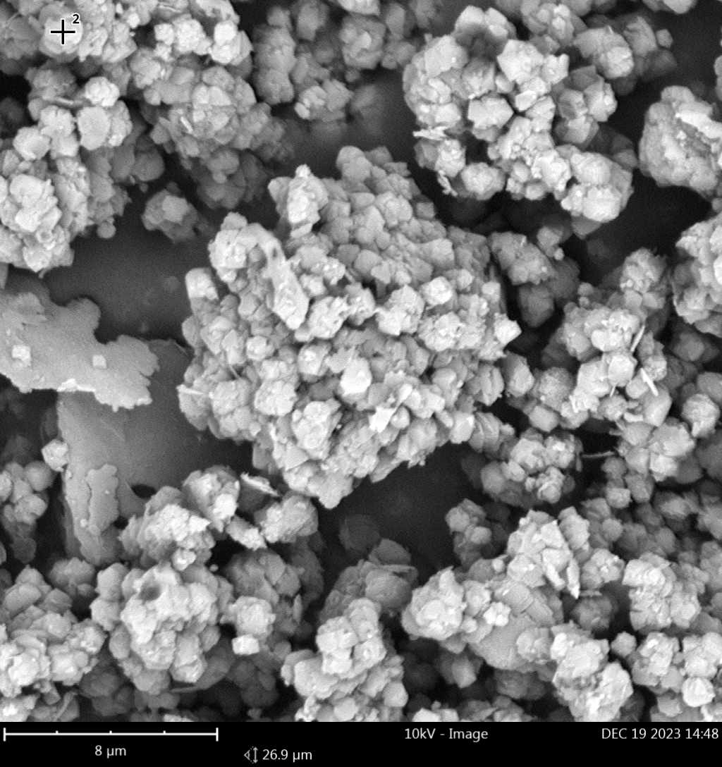 | 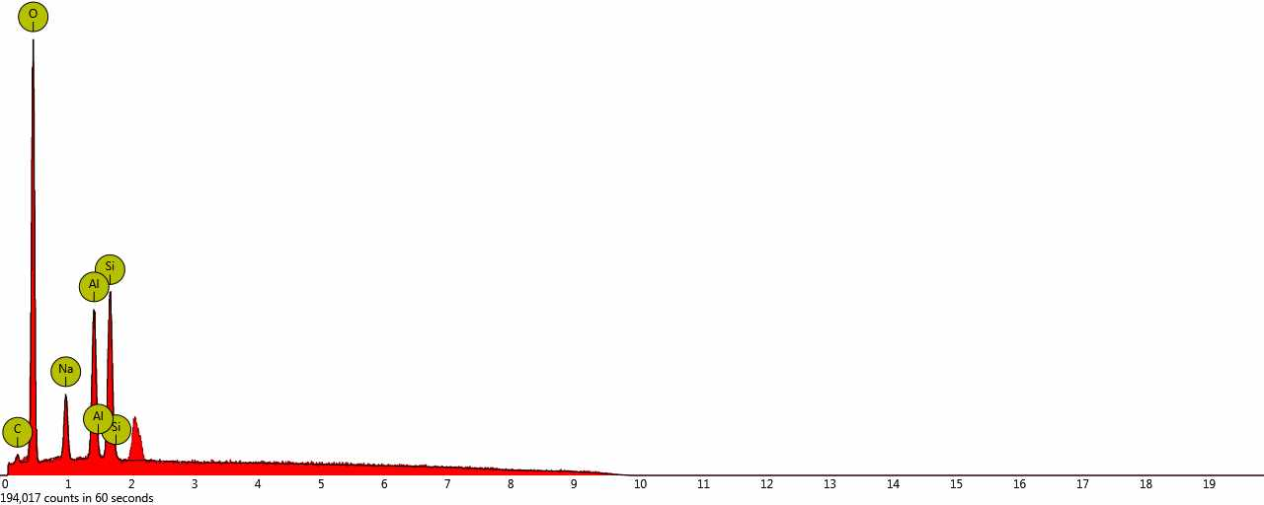
3c. spot |  | 4c. spot
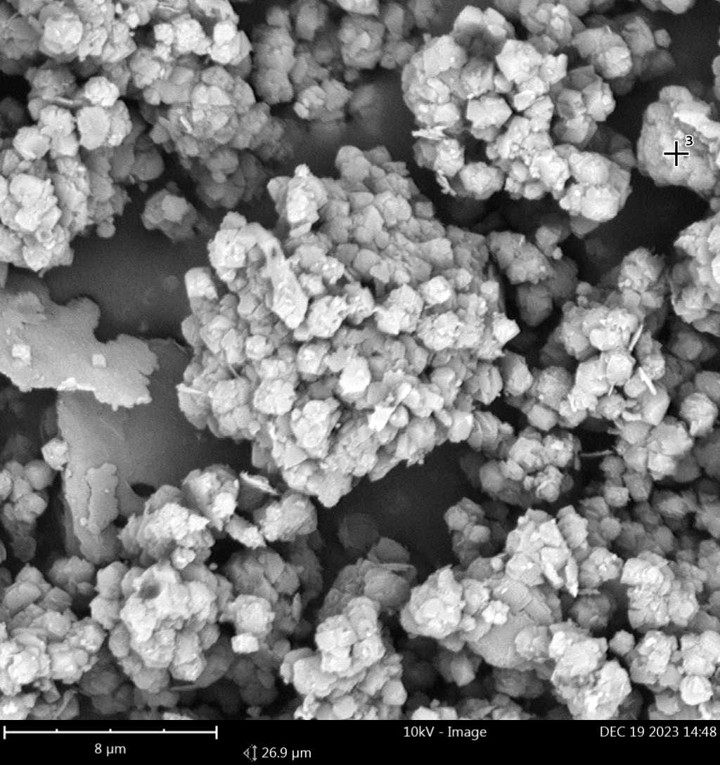 | 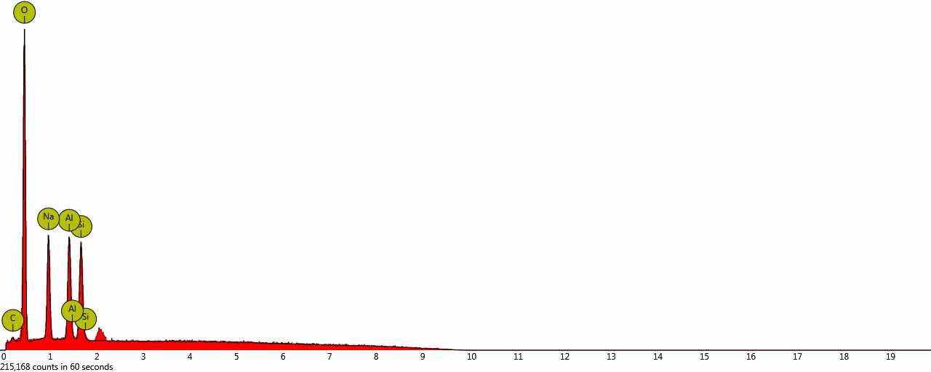 | 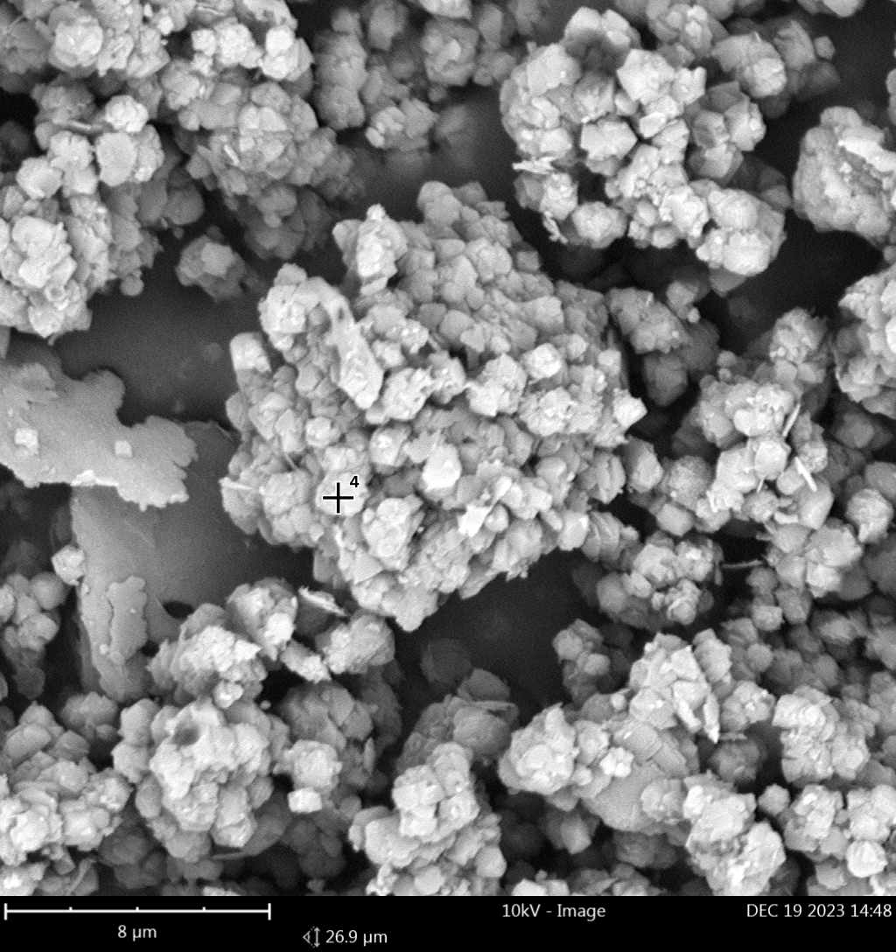 | 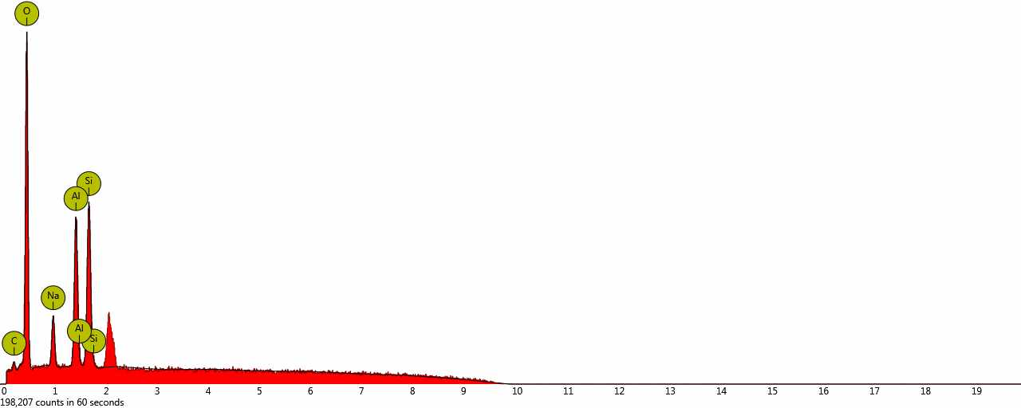
1d. spot |  | 2d. spot
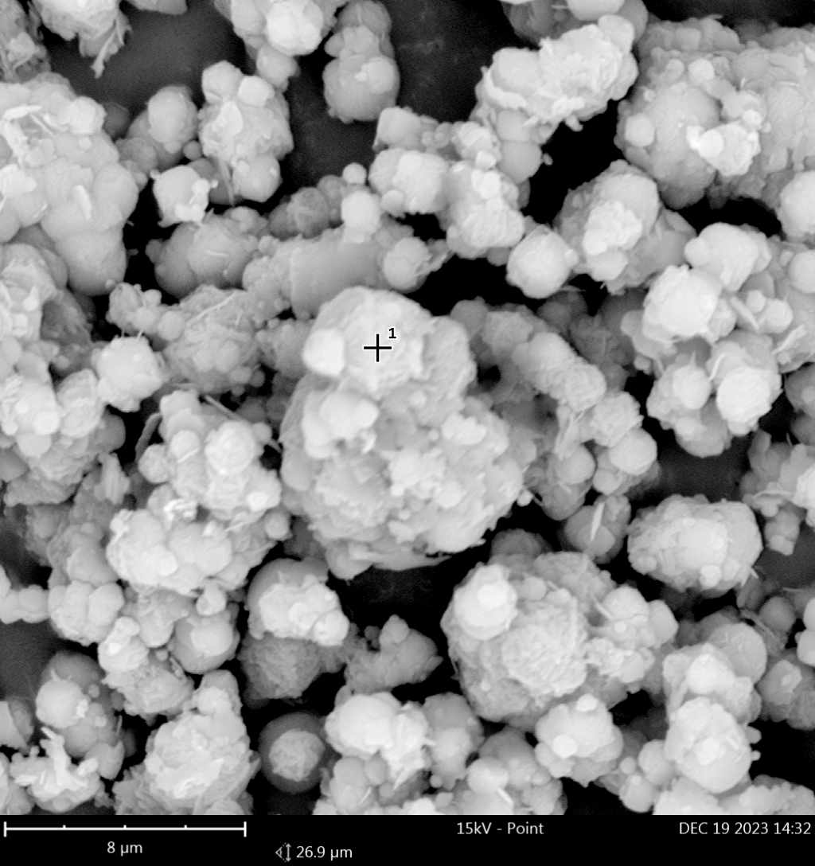 | 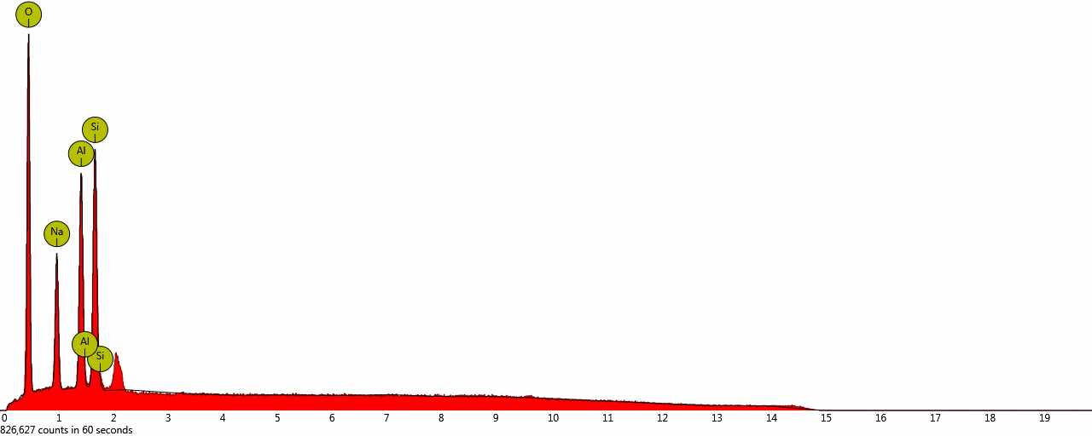 | 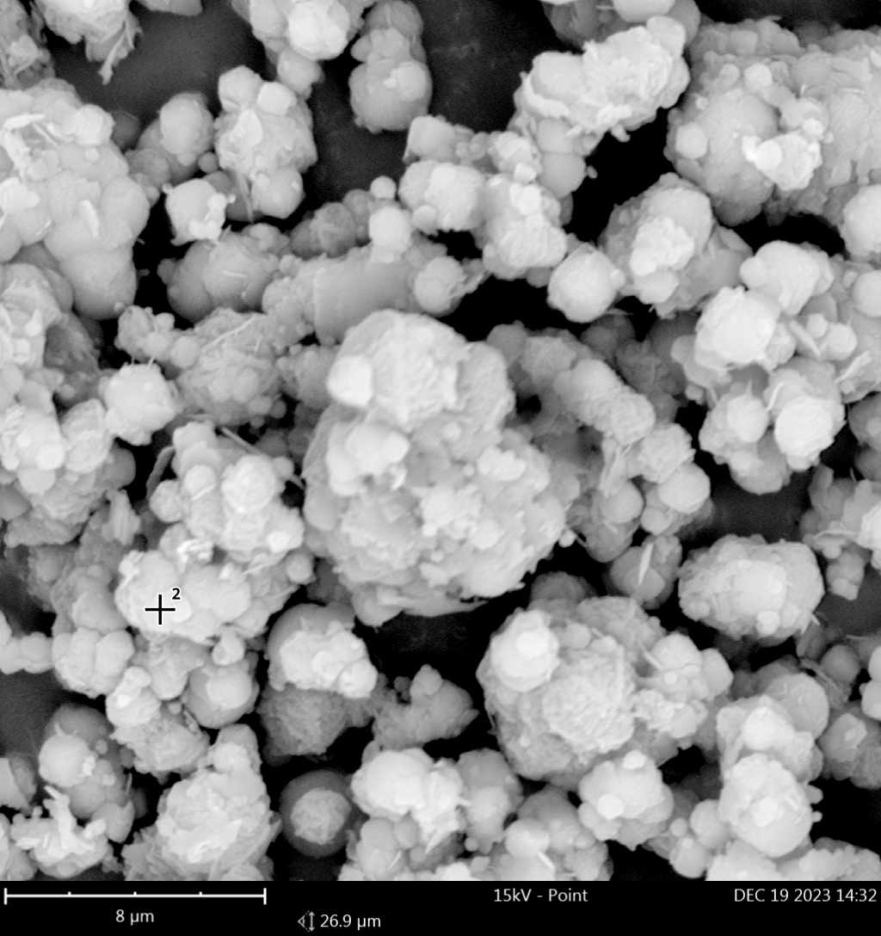 | 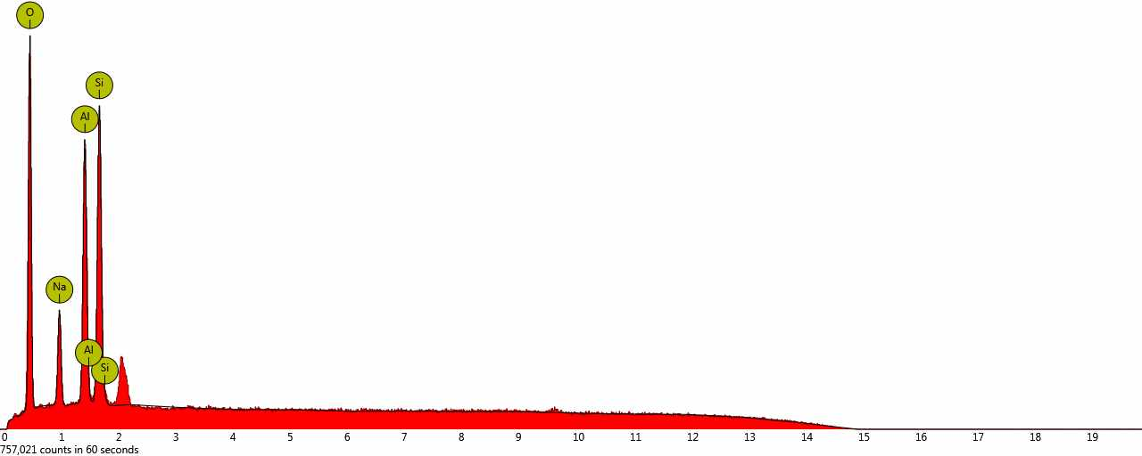
3d. spot |  | 4d. spot
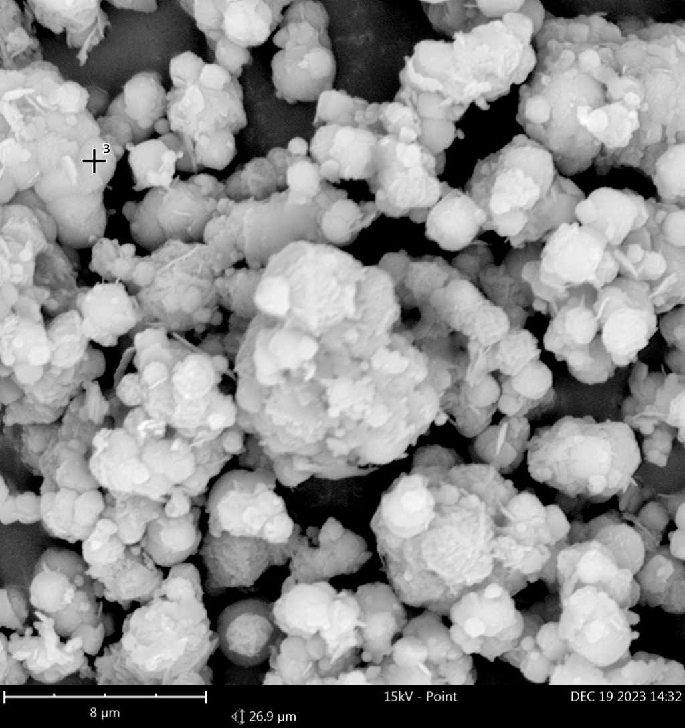 | 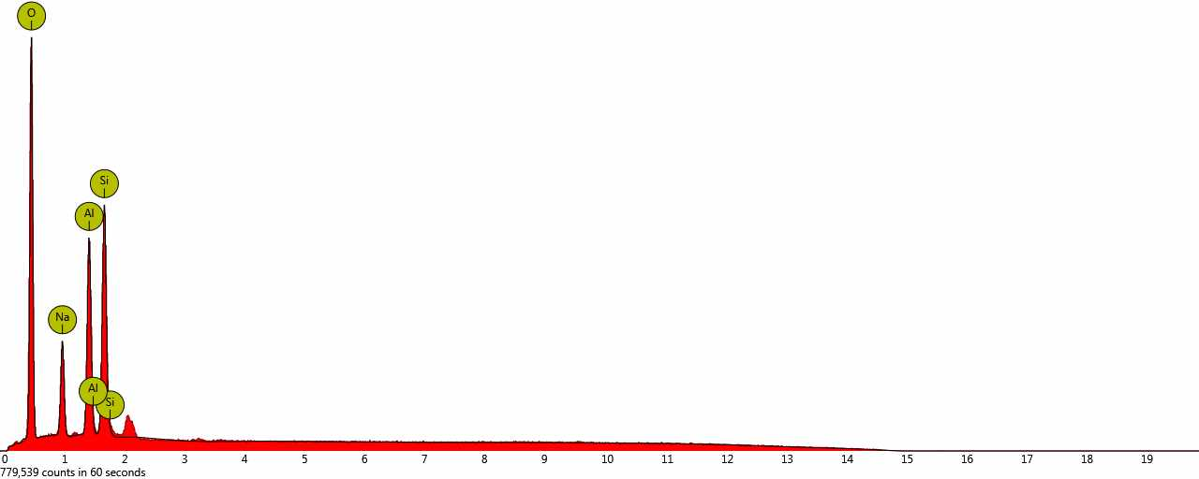 | 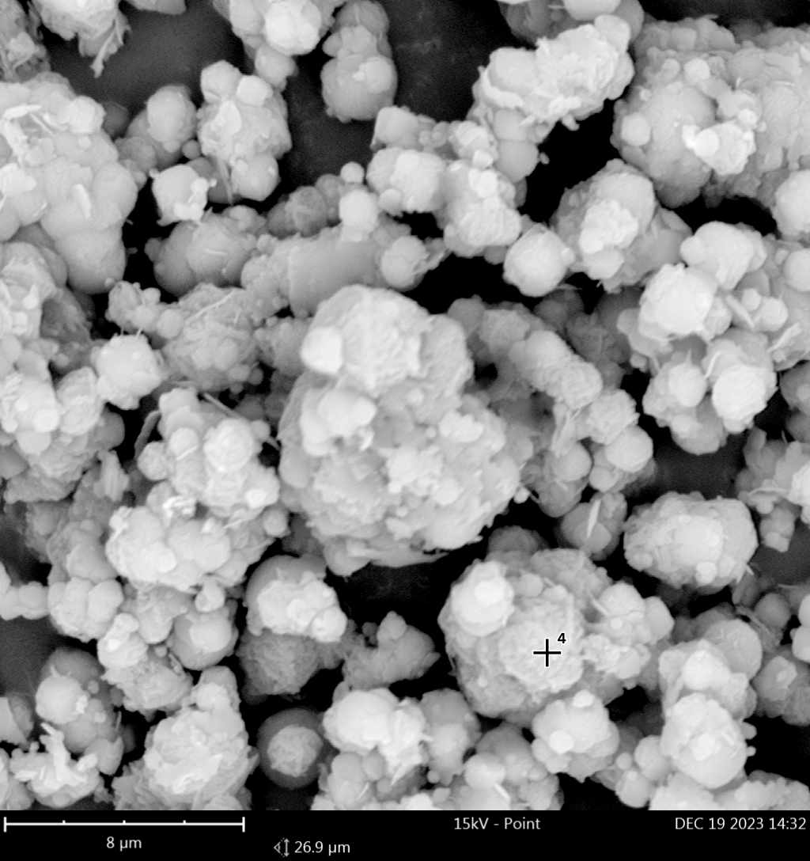 | 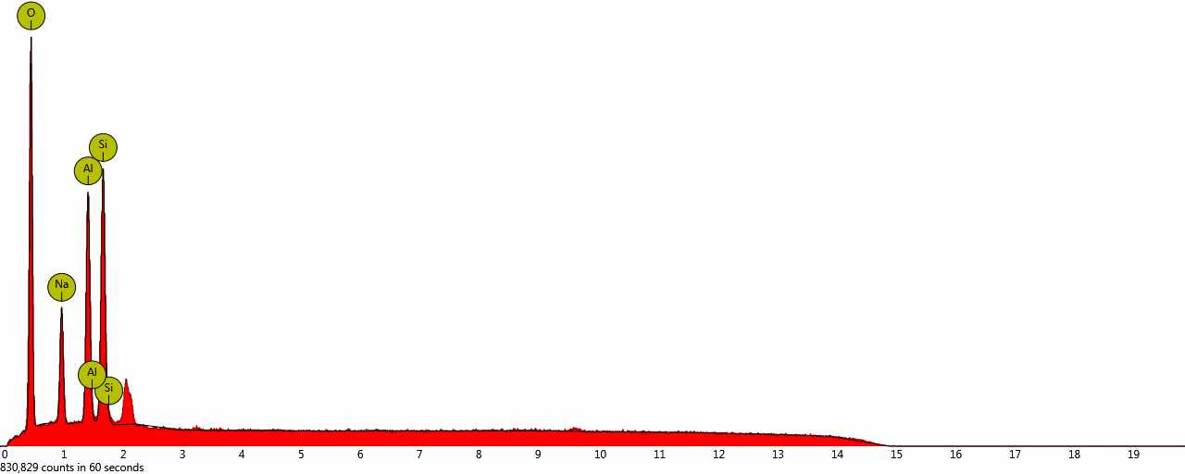
5d. spot |  | 6d. spot
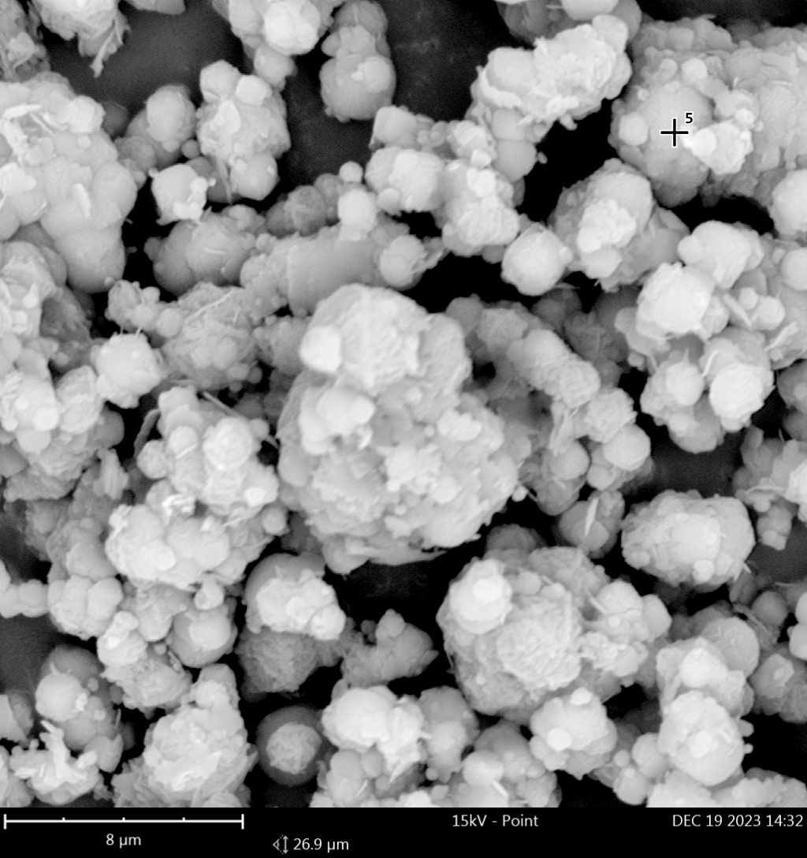 | 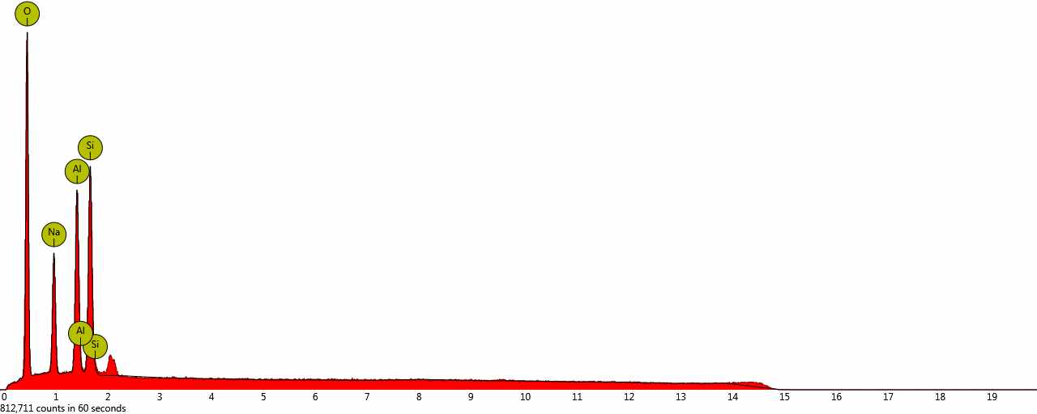 | 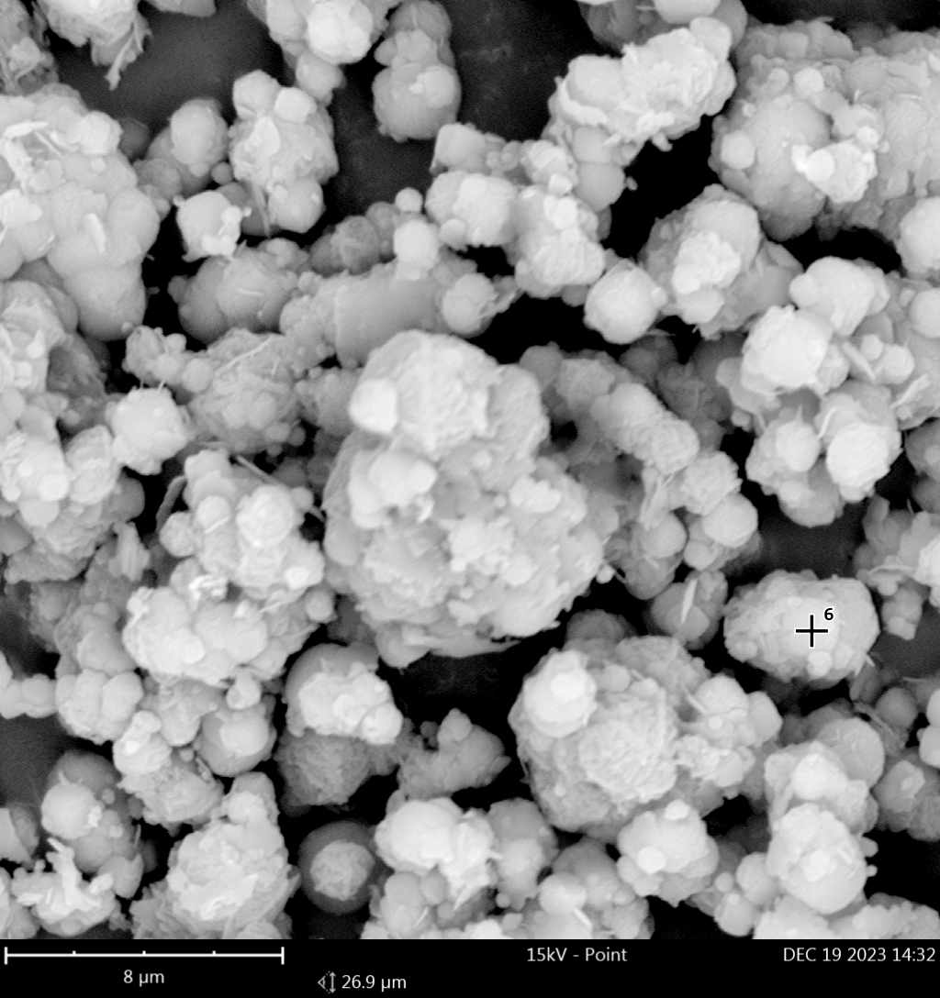 | 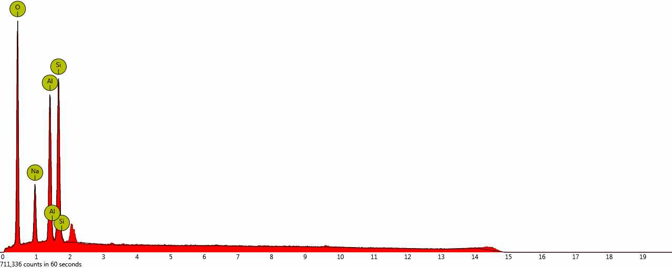
1e. spot |  | 2e. spot
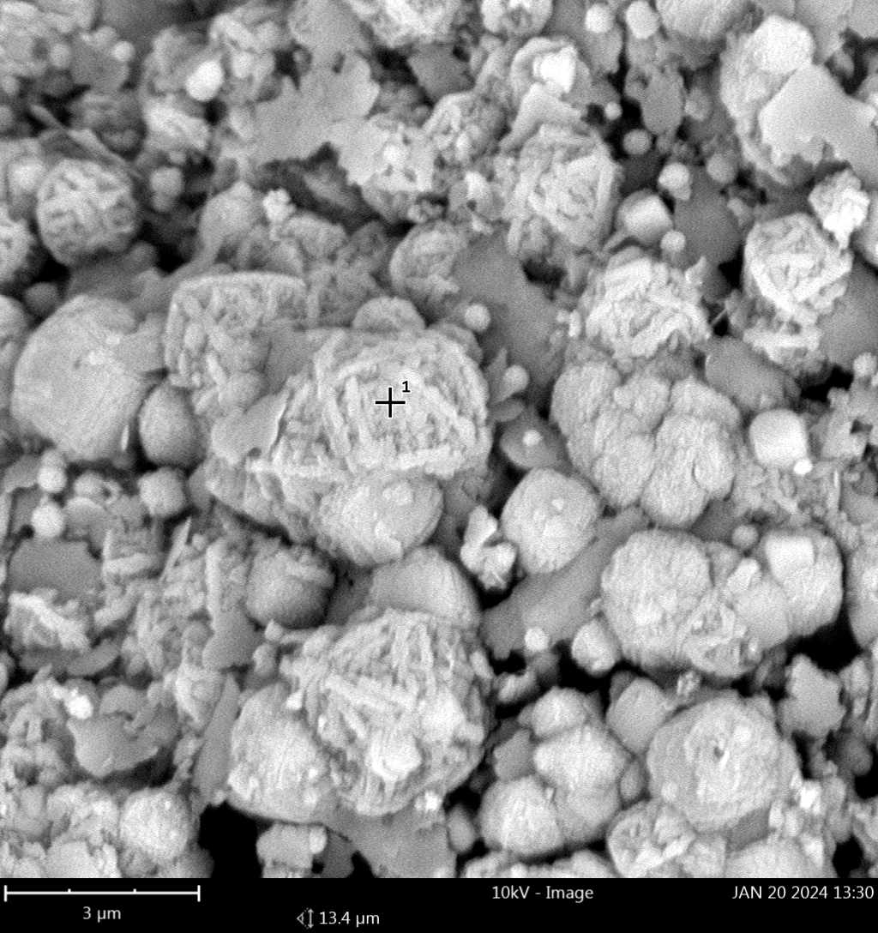 | 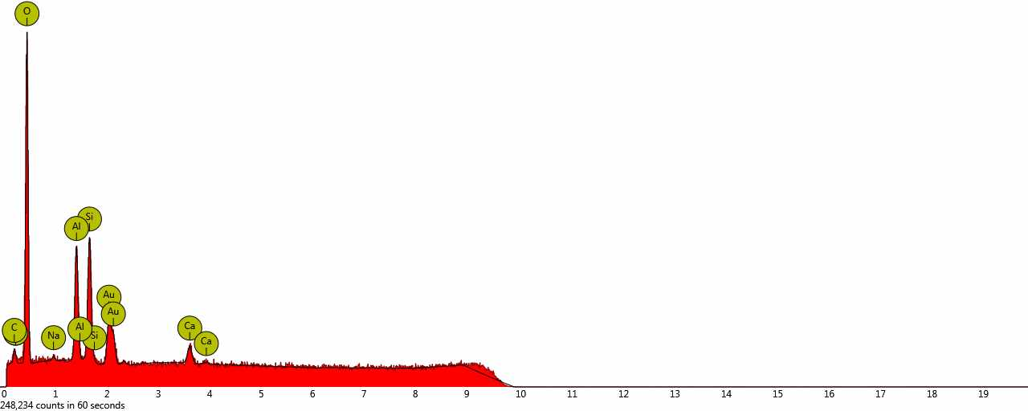 | 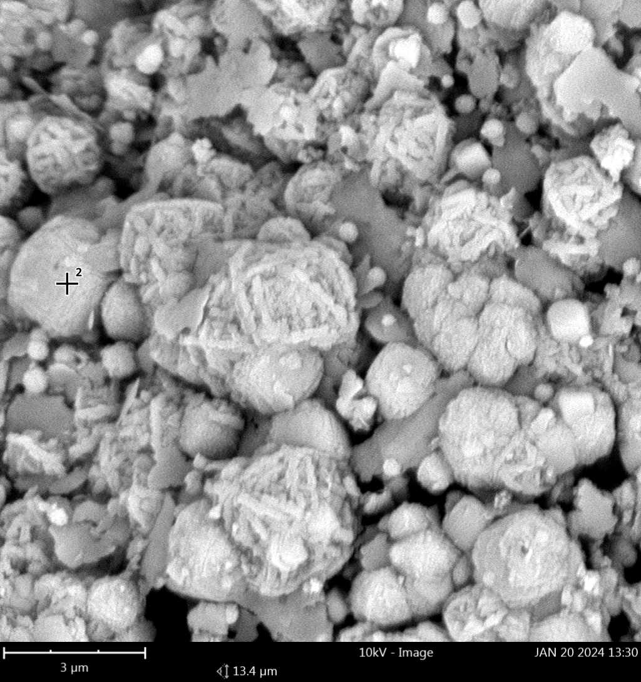 | 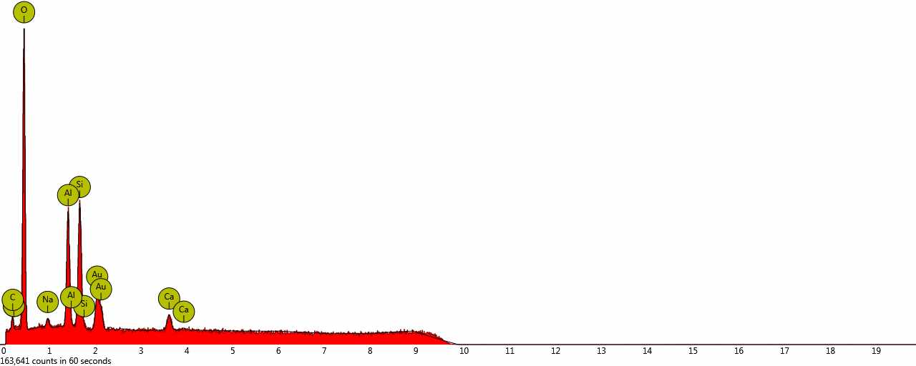
3e. spot |  | 4e. spot
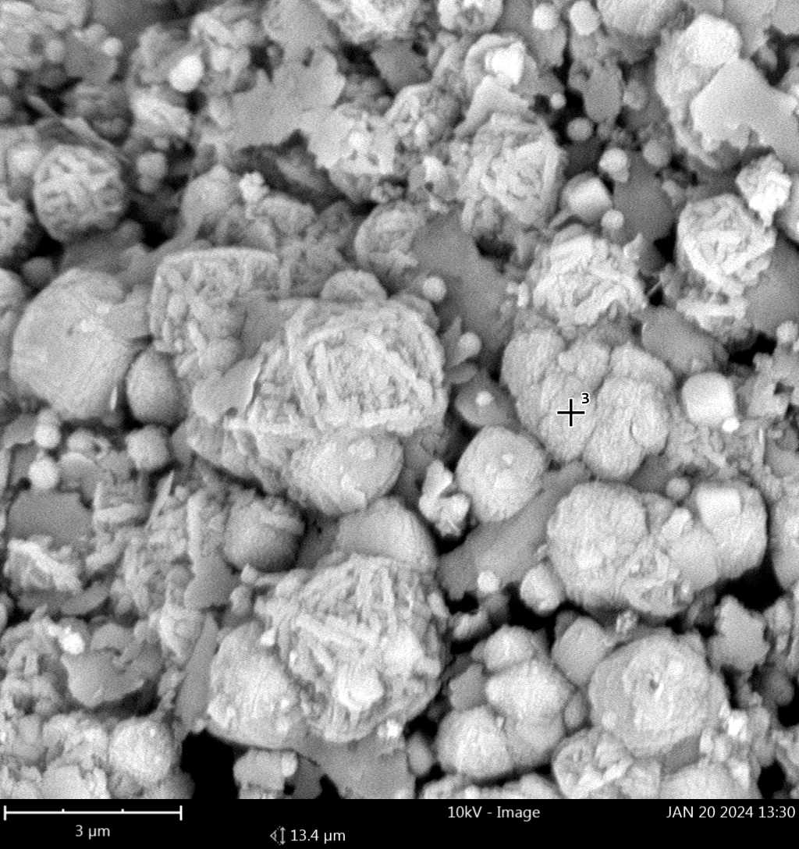 | 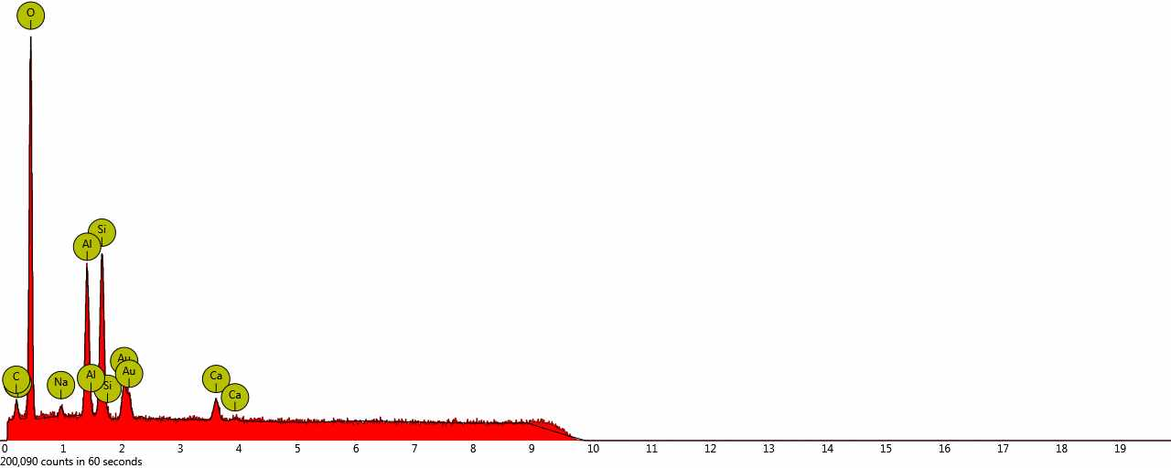 | 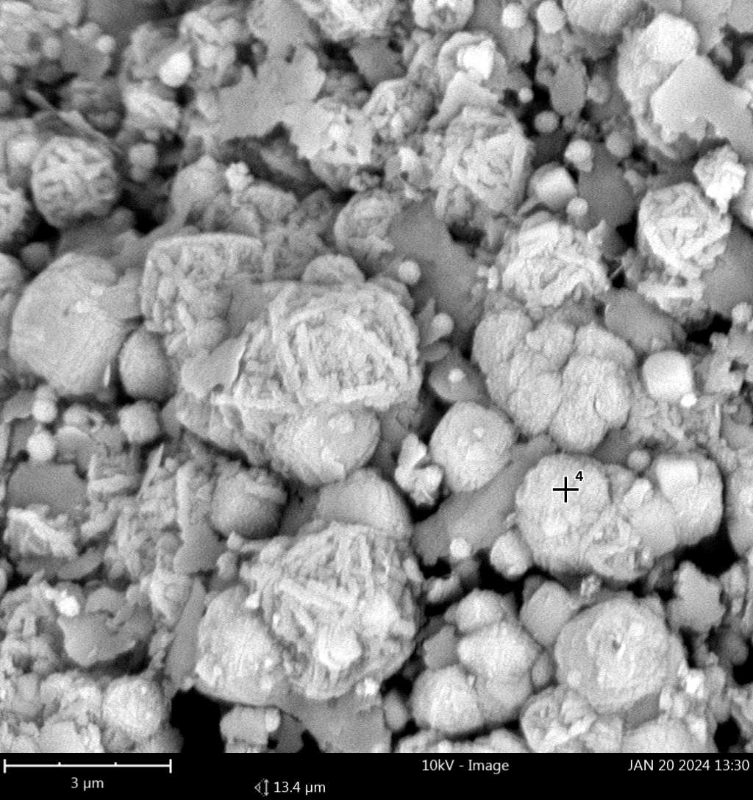 | 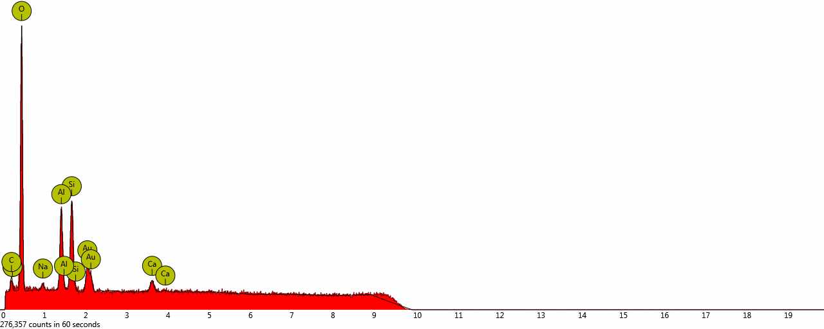
5e. spot |  | 6e. spot
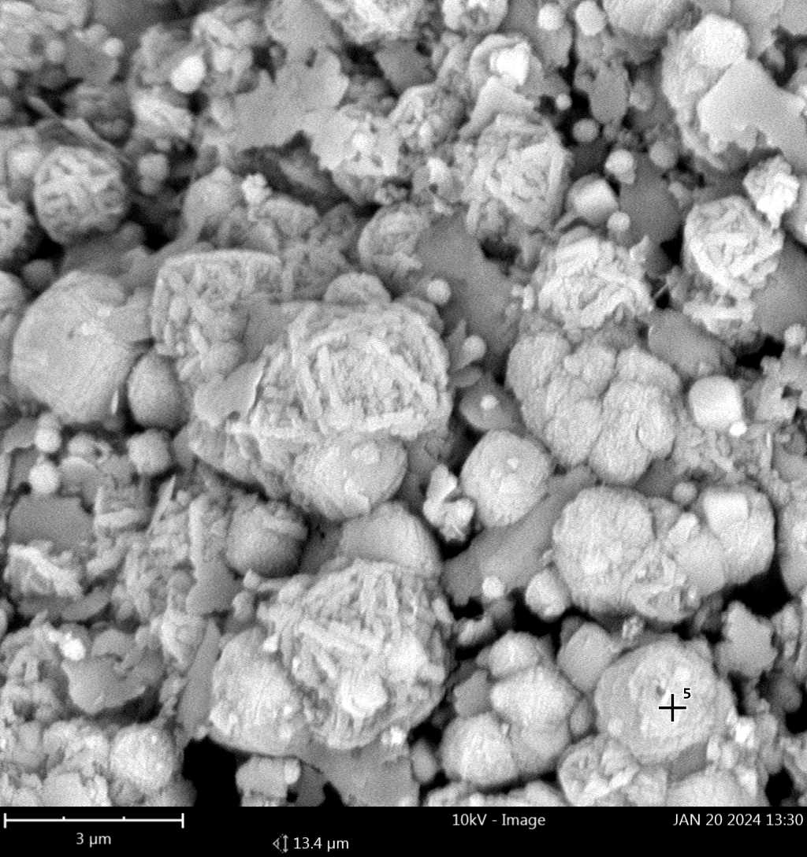 | 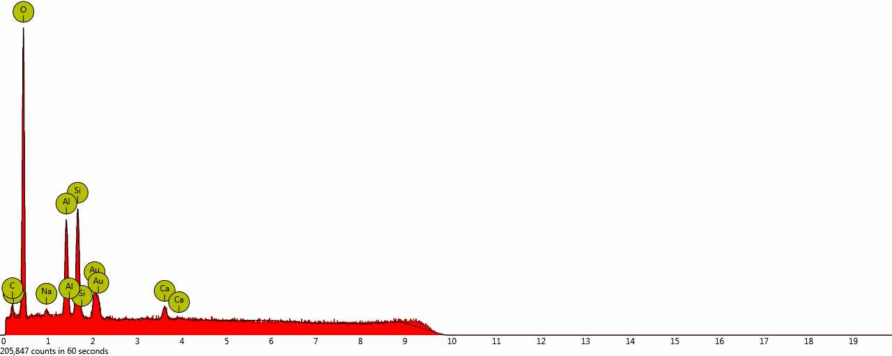 | 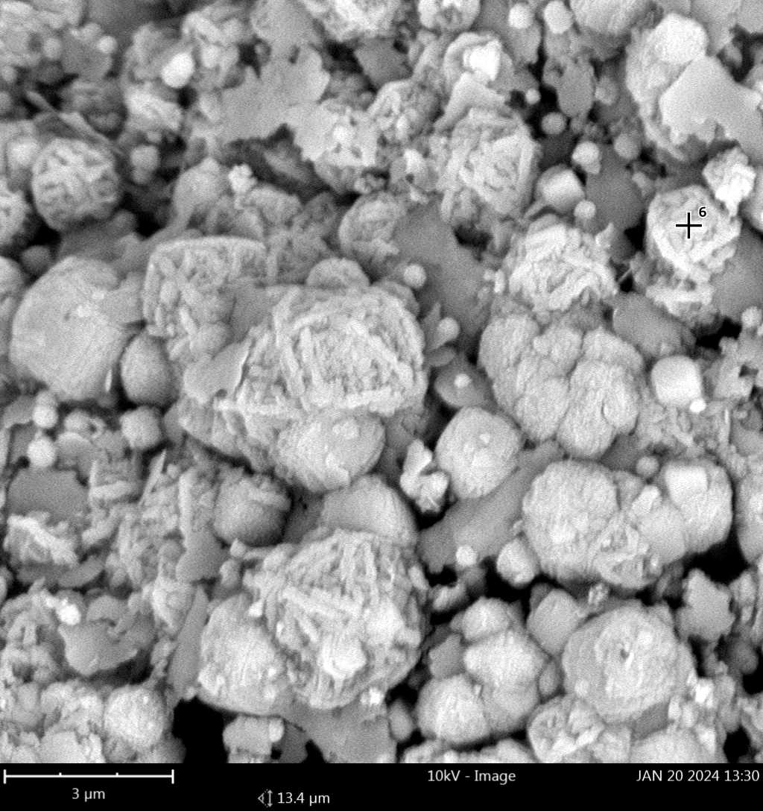 | 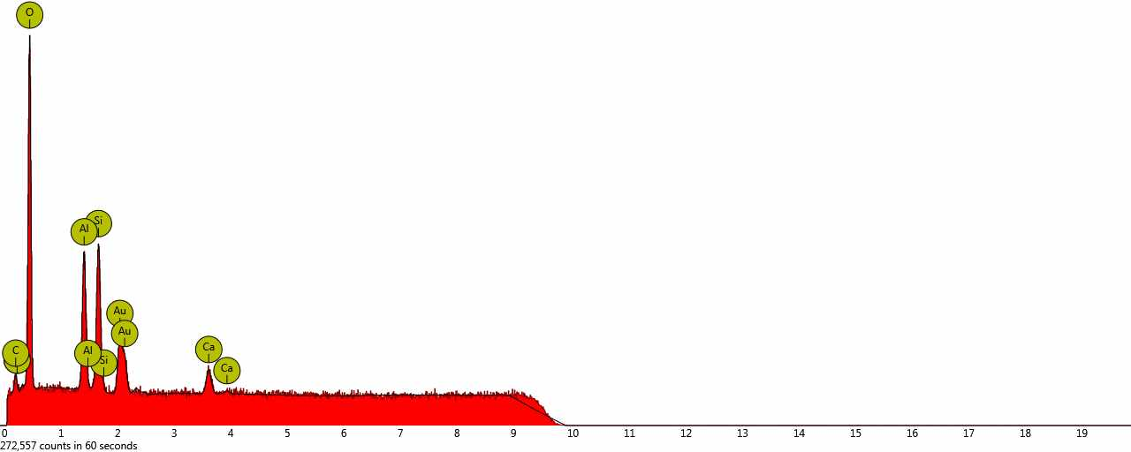
Figure 4: Correlated SEM-EDS microanalysis profiles of the precursors and synthesized structures evaluated across localized spot regions: raw Angren kaolin clay (spots 1a–4a); intermediate K4A-I framework (spots 1b–6b); intermediate K4A-II framework (spots 1c–4c); optimized K4A-III zeolite matrix (spots 1d–6d); calcium-exchanged 5A-III adsorbent (spots 1e–6e).
Analysis of the initial AKC-30 grade kaolin showed that its elemental composition is predominantly represented by oxygen, silicon, and aluminum, which is characteristic of aluminosilicate materials. Minor amounts of potassium, magnesium, and phosphorus were also detected as impurity components of the natural raw material.
The synthesized 4A zeolite samples (K4A-I, K4A-II, and K4A-III) are characterized by the presence of sodium, indicating the formation of the Na-form of zeolite and confirming the success of alkaline activation of kaolin. The Si/Al elemental ratio falls within the range typical of LTA-type zeolites. The minor carbon content observed at some analysis points is due to the use of carbon adhesive tape during sample preparation.
In the 5A-III zeolite samples obtained by ion exchange, the appearance of calcium was recorded, confirming the replacement of Na⁺ cations with Ca²⁺. Concurrently, a significant decrease in sodium content was observed, indicating the efficiency of the ion-exchange process. The presence of gold (Au) in the spectra is associated with the conductive coating applied prior to SEM analysis and is not related to the material composition.
Thus, the EDS analysis results confirm the successful formation of 4A and 5A zeolite structures and the correspondence of their elemental composition to the expected chemical nature of the synthesized adsorbents.
Conclusion
In this work, 4A and 5A zeolites intended for natural gas dehydration and the removal of acidic components were successfully synthesized utilizing raw kaolin from the Angren deposit. The structural, morphological, and compositional properties of the obtained crystalline matrices were systematically characterized using scanning electron microscopy (SEM), energy-dispersive X-ray spectroscopy (EDS), and X-ray diffraction (XRD).
The results of the elemental and morphological analyses confirmed the successful formation of a well-defined, highly crystalline LTA-type zeolite framework, as well as the efficiency of the post-synthetic ion-exchange process in yielding the Ca-form of the 5A zeolite. The competitive adsorption performance of the synthesized zeolites was rigorously evaluated based on their capacity to capture hydrogen sulfide (H₂S) from natural gas streams under dynamic conditions.
It was established that the dynamic adsorption capacity of the optimized 5A-III zeolite sample is three times higher than that of the commercially available, industrially produced 5A zeolite counterpart. These findings demonstrate the high efficiency of the 5A-III zeolite synthesized from local Angren kaolin precursors and strongly confirm its promising potential as a cost-effective, high-performance adsorbent for industrial natural gas purification and desulfurization.
References
Aripdjanov O.Yu., Kayumov J.S., Makhammatov M.M., 2025a, Interaction of sulphur and sulphur-containing compounds with amines, Universum: Technical Sciences, 133(3). [in Russian]
Aripdjanov O.Yu., Kayumov J.S., Makhammatov M.M., Kurbonov R.T., Shoyimov H.K., 2025b, The study of the properties of sulfuric compounds contained in oils, gases and gas condensates, Science and Innovation International Scientific Journal, 4(2), 51–54.
Aripdjanov O.Yu., 2024, Characterization of adsorption processes and their application in the field of gas production and purification, In: Proceedings of the III Tashkent International Congress on Modern Sciences, Tashkent Institute of Chemical Technology, April 22–23, pp. 387–390. [in Russian]
Li R., Ren X., Ma H., Wang B., 2017, A quasi-solid-phase approach to activate natural minerals for zeolite synthesis, ACS Sustainable Chemistry & Engineering, 5(4), 3233–3242.
Miao Q., Zhou Z., Yang J., Lu J., Yan S., Wang J., 2009, Synthesis of NaA zeolite from kaolin source, Frontiers of Chemical Engineering in China, 3(1), 8–11.
Nazarbekov M.K., Rakhmatov E.A., 2016, Methods of applying natural gas dehydration in the design of units in the gas industry, Problems of Energy and Resource Saving, (1-2), 188–193. [in Russian]
Pat. 2317945 RU, 2008, Method of preparing granulated A-type zeolite, Russian Federation.
Pulatov Kh.L., Shapatov F.O., 2023, Environmental analysis of causes and sources of formation during technological processes, Science and Innovation, 3.
Ren L., Wu Q., Yang C., Zhu L., Li C., Zhang P., Zhang H., Meng X., Xiao F.S., 2012, Solvent-free synthesis of zeolites from solid raw materials, Journal of the American Chemical Society, 134(37), 15173–15176.

